Office of the Scottish Road Works Commissioner



ROAD WORKS PERFORMANCE REPORT

01 April 2020 to 31 March 2021

Contents

1. Scottish Road Works Commissioner’s (SRWC’s) Introduction 4

2. Executive Summary 6

3. The Organisation 12

4. Monitoring 14

5. Trends from Indicator Reports 17

6. Quality of Utility Company Reinstatements 38

7. Commissioner Penalties 40

8. Promotion of Compliance and Good Practice 42

9. Consultations and Research 46

10. Scottish Road Works Register 48

11. Legislation 57

12. Annual Report and Accounts 59

13. Reflection and Forward Planning 60

Appendix A. List of Acronyms and Terms 62

Appendix B. List of Roads Authorities and Utilities 63

Appendix C. Extent of Engagement 66

Appendix D. Additional Indicator Reports 68

Authorising Context

This Report has been produced in accordance with the requirements set out in Schedule 2 of the Transport (Scotland) Act 2005, and covers the 12 month period from April 2020 to March 2021.

Appointment

Kevin Hamilton has been appointed as the 4th Scottish Road Works Commissioner for a period of 5 years and brings a wealth of experience having worked in the roads sector for some 29 years.

The Scottish Road Works Commissioner’s Role

The Scottish Road Works Commissioner is an independent public official, appointed by Scottish Ministers. The Office was established following enactment of the Transport (Scotland) Act 2005.

The Act states:

“[The Commissioner] will oversee improvements to the planning, co-ordination and quality of road works in Scotland.”

The general functions of the 2005 Act are to:

* monitor the carrying out of road works in Scotland
* promote compliance with the New Roads and Street Works Act 1991
* promote the pursuit of good practice

The specific functions of the 2005 Act are to:

* publish an annual report
* prepare an annual account
* keep a register to be known as the Scottish Road Works Register

Disclaimer

The views offered by the Commissioner within this document are his own and do not necessarily reflect the approach taken by previous Commissioners.

# Scottish Road Works Commissioner’s (SRWC’s) Introduction

I am pleased to present my second report since taking up office in November 2020, covering the period 1 April 2020 to 31 March 2021.

The start of the reporting period coincided with the start of the COVID-19 pandemic which placed unprecedented restrictions on daily life and business activities. Activity within the road works sector was significantly disrupted three months before some restrictions were lifted in mid-late June 2020. During this initial period, only essential and urgent works were undertaken, following Scottish Government advice.

From July onwards, restrictions on working were eased considerably and non-urgent road works were able to recommence. However, working practices had to reflect guidance in place and this meant that productivity was affected with schemes taking longer to deliver as a result. Working from home, staff sickness and the inability to recruit, mentor or train staff during the pandemic were all cited as issues affecting performance.

By the end of 2020, road works activity undertaken by many organisations in the utility sector appeared to be back to pre-pandemic levels and it was clear that in some sectors, work load had increased significantly. As a result, the total number of road works undertaken by utilities in 2020/21 was less than 1% lower than in the previous year.

However, the roads authority sector continued to suffer the effects of the pandemic throughout the whole reporting period, with staff being deployed to other duties. Road works activity was further affected by severe winter weather in early 2021 and as a result, overall road works activity by roads authorities was 25.4% lower than in the previous year.

These factors led me to reconsider how to monitor performance for this unique year and following consultation with the road works community, I decided to limit the assessment of performance to three key metrics and only cover the second half of the reporting year. This means that comparison with previous years is not possible.

Like many organisations, the work of my office has been affected to some extent. For example, I have been in post for a whole year but have not visited my office or met my team in person. However, the team has worked tirelessly and creatively to overcome the difficulties of the situation and I would like to thank them again for all their efforts.

The pandemic has had some positive impacts. With the climate emergency, we all have to do what we can to reduce our carbon consumption and remote working has almost completely eliminated travel impacts for my team. We intend to continue this with significantly reduced need for travel and a move to hybrid office/home working when the time comes.

The pandemic has delayed much of the implementation of the Transport (Scotland) Act 2019 with only one minor road works provision being commenced within the reporting period.

Finally, I would like to comment on the upgrade to the Scottish Road Works Register (SRWR) which was undertaken in July 2020 in the midst of the pandemic. Introducing a new IT system is fraught with difficulties at any time but to introduce a system at the height of the pandemic when everyone was working remotely posed particular challenges. I am delighted that the project was delivered on time, on budget and with only minor teething troubles. The system has been very well received by the road works community and all involved in its implementation are to be congratulated.

SRWR information is available to download as [Open Data](https://roadworks.scot/opendata) and through the [Scottish Road Works Online](https://www.roadworksscotland.org/) website.



Kevin Hamilton

Scottish Road Works Commissioner

# Executive Summary

## The Organisation

Permanent staffing levels remained constant over the period, with no turnover. Accountancy is still largely undertaken in-house with external chartered accountancy support as required. The staffing establishment remains well placed to deliver the requirements of the Transport (Scotland) Act 2005 and to address the governance required of a public office.

## Monitoring

Monitoring was severely affected by the initial arrival of the COVID-19 pandemic in March 2020 with monitoring put on hold during a period when all organisations were having to adapt to revised ways of working. These included the re-deployment of large numbers of staff to other tasks, new procedures for safe transportation, increased levels of sanitation and cleanliness and working from home.

The production of the quarterly SRWC performance dashboards was still maintained, however there were significant effects on compliance during the preliminary months with the Commissioner resigned to the possibility of disregarding a significant proportion of the reporting year. The quarterly dashboard continues to promote engagement with organisations and ensure that organisations understand their statutory duties.

## Performance Indicator Trends

The 5 year rolling period introduced previously has been put on hold due to the constraints placed on organisations during the pandemic. The performance information requires to be stand alone and it is hoped that some form of year on year trend analysis can be introduced in future publications.

Several areas remain in need of continuing improvement including:

* percentage of unplanned works registered by Scottish Water, SP Energy Networks, Scottish and Southern Electricity Networks and SGN
* overall performance of many smaller utility companies
* seasonal variance/fluctuation in the performance of roads authorities
* works registered per 100km of road network by roads authorities

Despite the resourcing challenges facing the Scottish road works community, it is important that organisations fully embrace the concept of continuous performance improvement which is key to the delivery of co-ordinated road works.

## Performance Reviews

Although the Annual Performance Reviews were issued to CEOs of all organisations undertaking road works in Scotland during the summer 2021, the levels of reporting information were greatly reduced to take account of the disruption caused in the first 6 months (April to September) of the year. It was generally accepted that during April to June, organisations struggled to maintain expected levels of compliance, whilst July to September was a period of stabilizing.

## Safety at Road Works

Safety at utility company road works and at roads authority works for roads purposes remained a key priority of the office whilst adhering to Scottish Government and Commissioner led COVID-19 directions.

## Utility Company Reinstatements

Improving the quality of utility company reinstatements remains a high office priority. It is not acceptable that utility companies leave legacy defects for roads authorities to repair.

An indication of the quality of reinstatements is found in the results of national coring programmes which sample and test the bituminous bound layers of utility company reinstatements. Programmes are undertaken by RAUC(S) every two to three years. The national coring programme commenced in March 2019 and looked at a 2% sample of utility company reinstatements undertaken between 1 April 2018 and 31 March 2019. The full report was published in June 2020 and available [here](https://roadworks.scot/sites/default/files/publications/add/NATIONAL%20CORING%20REPORT%202019-20%20PROGRAMME%20-%2030%20June%202019.pdf)

## Commissioner Penalties

The Commissioner issued penalties against six utility companies for failure to comply with Scottish road works legislation whilst placing cables and pipe work in roads during 2020-21.

## Promotion of Compliance and Good Practice

The promotion of compliance and good practice is fundamental to encouraging organisations undertaking road works to co-operate and co-ordinate. The office continued to engage proactively with the road works community throughout the reporting period.

## Consultations and Research

The SRWC continued to take an active role in the Scottish Road Research Board and related technical groups with virtual meetings being held quarterly. There were no active road works research projects during the reporting period.

## Scottish Road Works Register

Management and operation of the SRWR continued with the support of the SRWR Steering Group, the SRWR Systems Assurance Team and the RAUC(S) Gazetteer Group.

There was no significant loss of service recorded during the reporting period.

A major overhaul of the software used in the provision of the SRWR was introduced during the reporting period. The new software includes many enhancements to the functionality of the SRWR, improving the system for the user community

## Legislation

The implementation of the Transport (Scotland) Act 2019 was significantly delayed by the COVID-19 pandemic with only one minor provision being commenced within the reporting period.

The SRWC continued as a member of the road works Policy Development Group (PDG). The PDG reviews primary, secondary and tertiary road works legislation in Scotland and informs Scottish Government officials.

## Annual Report and Accounts

AZETS audited the 2020/21 SRWC Annual Report and Accounts during the summer of 2021.

## Reflection and Forward Planning

There is no doubt that the COVID-19 pandemic affected the planning and execution of road works in Scotland in a way that could never have been foreseen. This resulted in a revised framework for assessing individual organisation performance which aimed to reflect the very challenging circumstances everyone faced.

It is clear that many organisations were able to adjust working practices and by the end of the year had gone some way to returning to levels of work seen prior to the pandemic. However, it is apparent that the impact of the pandemic affected roads authorities more than it affected undertakers. Roads authorities continued to notice significantly fewer works right through to the end of the reporting period.

The work of the SRWC was impacted mainly in the area of direct engagement with organisations on-site but the rapid adoption of remote working ensured that the core operations of the office continued, albeit at a slightly reduced pace.

The pandemic has significantly delayed the commencement of the road works legislative reforms and the SRWC staff will continue to support the development of these reforms. Reflecting on 2020/21, the Scottish road works community continued to co-ordinate and co-operate collaboratively in consideration of the additional pressures placed upon each organisation by the pandemic.

Going forward, a revised business plan has been produced for 2021/22 and the SRWC’s Corporate Plan will be refreshed in the coming year. The office will look to move towards a hybrid working model to best meet the needs of staff whilst capitalising on the benefits of remote and office working.



* Source – Scottish Road Works Register  
** Source – Scottish Transport Statistics 2020

# The Organisation

Angus Carmichael stood down as Commissioner in September 2020 and following a short period when Transport Scotland assumed the duties and functions of Commissioner, Kevin Hamilton took over the role in November 2020.

The SRWC’s permanent staffing numbers remained unchanged during the reporting period and the current establishment consists of:

## Policy Manager

Key functions include monitoring compliance with legislation and governance, keeping regulations, codes of practice and advice notes under review, promoting good practice, managing requests under FOI(S)A and EI(S)R and media/complaint handling.

## Performance Manager

This role entails the management of indicators, management of statistical information, working with the community to improve compliance and drafting performance reviews.

## SRWR Manager

The key responsibility of this post is to manage the operation of the SRWR. The SRWR Manager is the primary contact with the provider of the register, currently Symology Ltd.

## Technical Standards Manager

This post provides the office with engineering support. The main priority is to drive improvements in the overall quality and standard of road works through increased scrutiny of road works sites across Scotland.

## Business Manager

This key role deals with the general administration of the office, in house accounting, enquiries from the public, statutory returns, invoicing, budget monitoring and management of the Commissioner’s diary.

# Monitoring

## Introduction

The duties of the SRWC include “monitoring the carrying out of works in roads in Scotland” to ensure that roads authorities and utility companies are meeting their statutory obligations.

The SRWC has been monitoring the performance of organisations since indicators were introduced in 2009. In parallel, roads authorities and utility companies have been improving their own use of management information, available from the SRWR, to monitor their own works. Over recent years, the general trend has been towards improvement, with reduced levels of non-compliance. The provision of better technology and user friendly interfaces in the SRWR, has merited greater organisation engagement, resulting in general improvements.

In June 2021 all roads authority and utility company CEOs respectively received their Annual Performance Review, in respect of performance during 2020/21. Performance reports are also available throughout the year in the SRWR for roads authorities and utility companies to interrogate, allowing individual organisations to monitor their own performance and take remedial action where necessary.

Five key questions are considered when monitoring performance:

* are roads authorities co-ordinating works on their roads?
* are utility companies co-operating with roads authorities?
* are works taking too long to complete?
* are works being carried out safely?
* are reinstatements in roads meeting the required standard?

## Performance Indicators

Indicator reports are used to identify trends in the performance of roads authorities and utility companies over time. A suite of indicator reports are available directly to roads authorities and utility companies with access to the SRWR. Organisations are encouraged to regularly interrogate the SRWR to monitor their own performance and take appropriate mitigating action.

SRWC indicator reports are continually reviewed and developed to ensure that they are relevant, up to date and transparent. Organisations are required to provide a written response when their performance is poor.

Quarterly performance dashboards capture key indicators and present them in a red/amber/green status report.

## Engagement and Improvement

Ongoing engagement is intended to improve performance without the need to take formal enforcement action. However due to the COVID-19 pandemic, engagement with individual organisations was greatly curtailed during the first 2 quarters of the reporting year as organisations fought to deliver services in extremely difficult circumstances. Many required the re-deployment of resources with the added disruption due to the introduction of social distancing and health and safety protocols.

A limited number of organisations met (virtually) with the SRWC to discuss their performance during 2020/21.

Discussions in relation to performance were held with the following Roads Authorities:

* Aberdeen City Council
* Aberdeenshire Council
* Angus Council
* Argyll & Bute Council
* City of Edinburgh Council
* Dundee City Council
* East Ayrshire Council
* East Lothian Council
* East Renfrewshire Council
* Falkirk Council
* Fife Council
* Glasgow City Council
* Inverclyde Council
* Midlothian Council
* North Ayrshire Council
* Perth & Kinross Council
* Scottish Borders Council
* South Lanarkshire Council
* Stirling Council
* Transport Scotland
* West Lothian Council
* West Dunbartonshire Council

and the following utility companies:

* Arqiva
* BT
* CityFibre
* Energy Asset Pipelines
* ES Pipelines Limited
* Gas Transportation Company
* Last Mile Electricity Limited
* Lothian Broadband
* Network Rail
* Scottish and Southern Electricity Networks
* Scottish Water
* SGN
* SP Energy Networks
* SSE Telecoms
* Verizon
* Virgin Media Group
* Zayo

# Trends from Indicator Reports

In recognising the disruption to individuals, businesses, organisation and the wider community caused by the pandemic, it was considered unreasonable to report on organisation performance in a similar way to previous reporting years.

The initial disruption from late March and into June resulted in a number of road works performance measures being disproportionally affected, negating their credibility as a yearly performance measure. There was then the need for organisations to re-programme projects to regain ‘lost ground’ after the restrictions were eased and the effects were evident well into late summer affecting Quarter 2 performance. Increasingly, it was apparent that the majority of organisations were managing to return to good levels of consistency for the majority of their indicators during Quarter 3 and into Quarter 4.

In March 2021, this office consulted the road works community and sought agreement to review performance differently, suggesting focus should be around the latter half of the year (October 2020 to March 2021). This approach was welcomed and deemed to be reasonable and a fair compromise in the exceptional circumstances of the past year.

Roads authorities have a statutory duty to co-ordinate the execution of works of all kinds in roads for which they are responsible, whilst undertakers have a statutory duty to use their best endeavours to co-operate with the road works authority and with other undertakers.

These endeavours are both in terms of section 118(1) and section 119(1) respectively of the New Roads and Street Works Act 1991 (the 1991 Act) and are to ensure that road works are carried out:

* in the interests of safety;
* to minimise inconvenience to persons using the road; and
* to protect the structure of the road and integrity of apparatus in it.

The approach taken therefore focused on two aspects of co-ordination and co-operation, reviewing the aggregated value of the Q3/Q4 performance for Noticing Failures and Unplanned Works.

In addition due to the initial disruption and increases in non-compliance, it was necessary to revise the existing year threshold for noticing failures and align organisation’s performance against the sector median. Assessment of performance was either ‘Well Managed’ (<4% - the base SRWC target), ‘Satisfactory’ (< the sector median), or Unsatisfactory (> the sector median). See Table 1 and Table 2.

For Unplanned Works, performance levels in the majority of cases had returned to pre-pandemic levels so the performance assessments were based around existing SRWC targets for each relevant sector and either ‘Well Managed’, if below the target, or ‘Unsatisfactory’ if above the target. See Table 3 and Table 4.

## Improvement Plans

SRWC Improvement Plans were introduced in 2017/18. The following roads authority and utility companies continued to meet with the Commissioner and develop plans to improve their performance in 2020/21:

* City of Edinburgh Council
* Energy Asset Pipelines
* ES Pipelines Limited
* Fulcrum Pipeline Limited

Following review meetings, the following organisations were removed from the Improvement Plan process:

* Aberdeen City Council
* Aberdeenshire Council
* Gas Transportation Company
* Glasgow City Council
* Highland Council
* Last Mile Electricity Ltd
* Last Mile Gas Ltd
* Verizon
* West Dunbartonshire Council
* Zayo

## Compliance with Commissioner Guidance

It was deemed necessary to measure individual compliance with the initial directions issued by the SRWC at the start of the pandemic to instruct individual organisations to deliver emergency works only. These directions were further refined to include the statement within the works description field, “Essential works under COVID-19 guidance” for planned works where a delay would be detrimental to the wellbeing of society. These directions were to ensure that the risk to the work force and the public was minimised and would also reduce the number of works taking place on the network.

In order to achieve a rating of ‘well managed’, compliance had to be 75% or greater (see Table 5 and Table 6).

In previous versions of the Scottish Road Works Commissioners Annual Report, analysis considered trends over the a five year period. However, due to the disruption, this report is delivered as a unique variant and on reviewing current performance, this historic approach should be re-introduced in 2021-22. In addition, it is intended that the full suite of indicators will be considered next year.

### Roads authority and utility company noticing failures as a percentage of actual starts

All qualifying road works carried out by utility companies and roads authorities are required to be registered (noticed) on the Scottish Road Works Register (SRWR).

Utility company noticing failures are system generated by the SRWR and referred to as potential noticing offences. Each potential noticing offence is reviewed by a roads authority and may attract a Fixed Penalty Notice (FPN) (not all roads authorities have taken up the option to issue FPNs).

Roads authority noticing failures are also system generated by the SRWR and referred to as potential noticing failures for comparison purposes with utility company performance. They are not subject to FPNs as an authority cannot issue a penalty against themselves.

This indicator compares the average noticing failure rate of all utility companies against the average noticing failure rate of all roads authorities and the individual failure rates of utility companies and roads authorities.

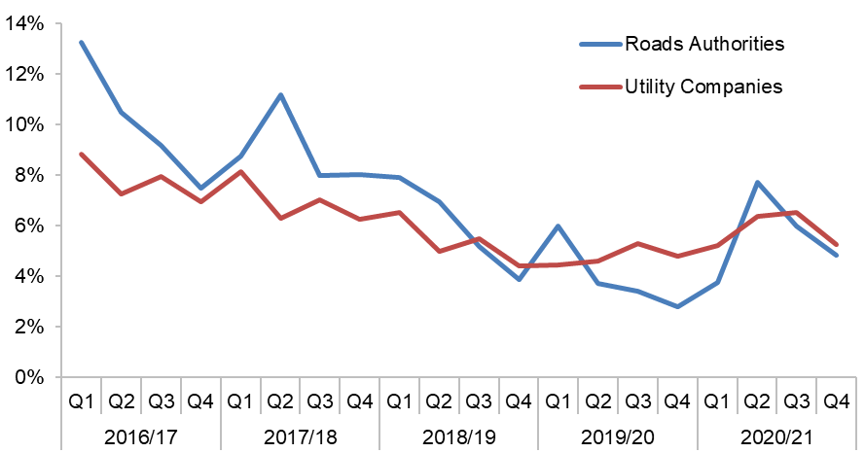

| Period | Roads Authorities | Utility Companies |
| --- | --- | --- |
| 2016/17 Q1 | 13.2% | 8.8% |
| 2016/17 Q2 | 10.5% | 7.2% |
| 2016/17 Q3 | 9.2% | 8.0% |
| 2016/17 Q4 | 7.5% | 6.9% |
| 2017/18 Q1 | 8.7% | 8.1% |
| 2017/18 Q2 | 11.2% | 6.3% |
| 2017/18 Q3 | 8.0% | 7.0% |
| 2017/18 Q4 | 8.0% | 6.3% |
| 2018/19 Q1 | 7.9% | 6.5% |
| 2018/19 Q2 | 7.0% | 5.0% |
| 2018/19 Q3 | 5.2% | 5.5% |
| 2018/19 Q4 | 3.9% | 4.4% |
| 2019/20 Q1 | 6.0% | 4.4% |
| 2019/20 Q2 | 3.7% | 4.6% |
| 2019/20 Q3 | 3.4% | 5.3% |
| 2019/20 Q4 | 2.8% | 4.8% |
| 2020/21 Q1 | 3.8% | 5.2% |
| 2020/21 Q2 | 7.7% | 6.4% |
| 2020/21 Q3 | 6.0% | 6.5% |
| 2020/21 Q4 | 4.8% | 5.2% |

Figure - Roads authority and utility company noticing failures

(Source: SRWR Reports 2a and 2b)

The COVID-19 pandemic affected all aspects of business during the period from March 2020, and the delivery of road works on the road network by individual organisations was very different. What was different was how quickly organisations transitioned from the initial disruption caused to a ‘normal’ business as usual.

The Roads authority sector was significantly affected by pressures to ensure essential services were being maintained and in the vast majority of authorities road works operations were curtailed and staff re-deployed to other duties. In many areas, Roads authorities report that they are still coping with reduced resources and staff absences due to the pandemic.

The statutory undertaker sector in the main did not suffer the disruption enforced by internal wholesale staff re-deployment and has managed the return to near pre- pandemic work volumes, driven by business critical need.

Roads authorities reduced work volumes by over 60% in Q1 compared to the same period in 2019/20, with the provision of the design and implementation of ‘Spaces for People’ projects and staff re-deployment, technical issues with home working and staff inexperienced in road work register processes. These issues continued through Q2 and beyond.

In contrast, utility companies, although reducing their work volumes by approx. 22% during Q1 did not suffer from enforced resource re-deployment and work volumes increased quickly through Q2. Staff familiar with the road works management processes were responsible for limiting any significant deterioration in noticing compliance.

| Organisation | 2020/21 Q3/Q4% | Rating |
| --- | --- | --- |
| Comhairle nan Eilean Siar | 0.7% | Well Managed |
| Renfrewshire Council | 1.2% | Well Managed |
| East Dunbartonshire Council | 1.3% | Well Managed |
| Perth & Kinross Council | 1.4% | Well Managed |
| Inverclyde Council | 2.0% | Well Managed |
| East Renfrewshire Council | 2.5% | Well Managed |
| Transport Scotland | 2.7% | Well Managed |
| North Lanarkshire Council | 3.1% | Well Managed |
| West Dunbartonshire Council | 3.2% | Well Managed |
| Aberdeen City Council | 3.9% | Well Managed |
| South Ayrshire Council | 3.9% | Well Managed |
| Aberdeenshire Council | 4.1% | Satisfactory |
| West Lothian Council | 4.2% | Satisfactory |
| Shetland Islands Council | 4.4% | Satisfactory |
| South Lanarkshire Council | 5.2% | Satisfactory |
| Angus Council | 5.4% | Satisfactory |
| Fife Council | 6.3% | Satisfactory |
| Scottish Borders Council | 6.5% | Unsatisfactory |
| Argyll & Bute Council | 6.6% | Unsatisfactory |
| Midlothian Council | 6.6% | Unsatisfactory |
| City of Edinburgh Council | 6.9% | Unsatisfactory |
| Falkirk Council | 7.2% | Unsatisfactory |
| Clackmannanshire Council | 9.2% | Unsatisfactory |
| East Ayrshire Council | 10.0% | Unsatisfactory |
| Highland Council | 11.0% | Unsatisfactory |
| Moray Council | 12.3% | Unsatisfactory |
| North Ayrshire Council | 14.7% | Unsatisfactory |
| Orkney Islands Council | 14.9% | Unsatisfactory |
| Stirling Council | 15.4% | Unsatisfactory |
| Dumfries & Galloway Council | 16.8% | Unsatisfactory |
| East Lothian Council | 20.7% | Unsatisfactory |
| Glasgow City Council | 20.9% | Unsatisfactory |
| Dundee City Council | 21.2% | Unsatisfactory |
| Tay Bridge Joint Board | 200.0% | Unsatisfactory |

Table - Roads authority noticing failures as a % of actual starts in Q3/Q4

(Source: SRWR Report 2a)

| Organisation | 2020/21 Q3/Q4% | Rating |
| --- | --- | --- |
| Arqiva | 0.0% | Well Managed |
| CenturyLink | 0.0% | Well Managed |
| Commsworld Ltd | 0.0% | Well Managed |
| GTC Pipelines Ltd | 0.0% | Well Managed |
| INEOS FPS | 0.0% | Well Managed |
| Lothian Broadband | 0.0% | Well Managed |
| Sky Uk | 0.0% | Well Managed |
| Verizon | 0.0% | Well Managed |
| Network Rail | 3.0% | Well Managed |
| Scottish Water | 3.4% | Well Managed |
| BT | 4.0% | Satisfactory |
| Last Mile Gas Limited | 4.2% | Satisfactory |
| Vodafone | 5.4% | Satisfactory |
| Last Mile Electricity Ltd | 5.5% | Satisfactory |
| CityFibre | 5.8% | Satisfactory |
| EE | 6.0% | Unsatisfactory |
| SP Energy Networks | 6.3% | Unsatisfactory |
| SSE Telecoms | 6.6% | Unsatisfactory |
| SGN | 7.0% | Unsatisfactory |
| Energy Asset Pipelines | 7.3% | Unsatisfactory |
| Telefonica UK | 9.8% | Unsatisfactory |
| Scottish & Southern Electricity Networks | 10.6% | Unsatisfactory |
| Virgin Media Group | 11.4% | Unsatisfactory |
| Axione UK Ltd | 13.2% | Unsatisfactory |
| Zayo | 15.0% | Unsatisfactory |
| Hyperoptic | 22.0% | Unsatisfactory |
| ES Pipelines Ltd | 50.9% | Unsatisfactory |
| Fulcrum Pipeline Ltd | 57.1% | Unsatisfactory |
| Murphy Power Distribution Ltd | 87.5% | Unsatisfactory |
| Royal Mail | 181.8% | Unsatisfactory |

Table - Utility companies noticing failures as a % of actual starts in Q3/Q4

(Source: SRWR Reports 2b)

### Unplanned works as a percentage of actual starts

Where works are considered, by a roads authority or utility company to be emergency, urgent or remedial dangerous they are considered to be unplanned works and there are special noticing procedures which allow works to start as soon as possible.

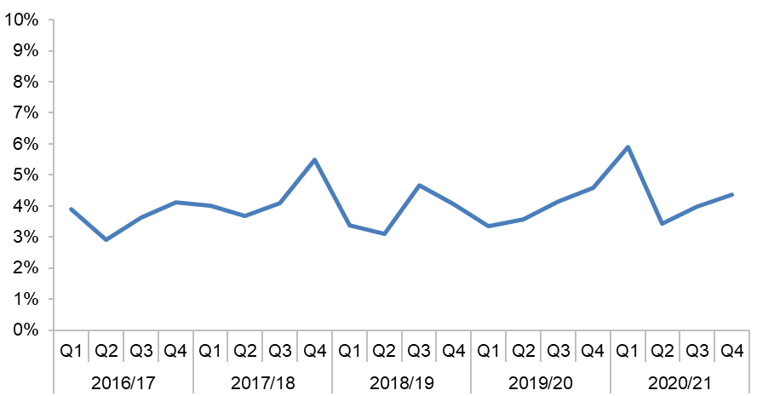

| Period | Roads Authority |
| --- | --- |
| 2016/17 Q1 | 3.9% |
| 2016/17 Q2 | 2.9% |
| 2016/17 Q3 | 3.6% |
| 2016/17 Q4 | 4.1% |
| 2017/18 Q1 | 4.0% |
| 2017/18 Q2 | 3.7% |
| 2017/18 Q3 | 4.1% |
| 2017/18 Q4 | 5.5% |
| 2018/19 Q1 | 3.4% |
| 2018/19 Q2 | 3.1% |
| 2018/19 Q3 | 4.7% |
| 2018/19 Q4 | 4.1% |
| 2019/20 Q1 | 3.3% |
| 2019/20 Q2 | 3.6% |
| 2019/20 Q3 | 4.1% |
| 2019/20 Q4 | 4.6% |
| 2020/21 Q1 | 5.9% |
| 2020/21 Q2 | 3.4% |
| 2020/21 Q3 | 4.0% |
| 2020/21 Q4 | 4.4% |

Figure - Roads authorities quarterly unplanned works as a % of actual starts

(Source: SRWR Report 9a)

The Scottish Road Works commissioner issued directions to the RAUC(s) community providing information on what type of essential works could continue during the onset of the COVID-19 pandemic to add substance to the Scottish Government’s guidelines that all works should be curtailed. Initially, Emergency, Urgent (Unplanned) works were allowed to ensure that any safety risks associated with the failure of utility service infrastructure could be avoided.

Historically roads authorities have less need to implement unplanned work, unless as a result of structural damage or flooding, whilst the main service providers (Electricity, Gas & Water providers) have a legal requirement to limit service outages.

It is apparent that both the roads authorities and utility companies undertook unplanned works and in combination with reduced work volumes, significant increases were evidenced in Q1.

Table 3 provides details of performance for the aggregated Q3/Q4 performance for each of the individual Roads Authorities.

| Organisation | 2020/21 Q3/Q4% | Rating |
| --- | --- | --- |
| Angus Council | 0.0% | Well Managed |
| Tay Bridge Joint Board | 0.0% | Well Managed |
| North Lanarkshire Council | 0.4% | Well Managed |
| Dundee City Council | 0.8% | Well Managed |
| West Lothian Council | 1.0% | Well Managed |
| East Ayrshire Council | 1.1% | Well Managed |
| Inverclyde Council | 1.3% | Well Managed |
| South Lanarkshire Council | 1.6% | Well Managed |
| Transport Scotland | 1.6% | Well Managed |
| Midlothian Council | 1.9% | Well Managed |
| East Dunbartonshire Council | 2.0% | Well Managed |
| Shetland Islands Council | 2.2% | Well Managed |
| South Ayrshire Council | 2.2% | Well Managed |
| Falkirk Council | 2.2% | Well Managed |
| Orkney Islands Council | 2.3% | Well Managed |
| East Renfrewshire Council | 2.5% | Well Managed |
| Moray Council | 2.9% | Well Managed |
| West Dunbartonshire Council | 3.2% | Well Managed |
| North Ayrshire Council | 3.3% | Well Managed |
| Clackmannanshire Council | 3.3% | Well Managed |
| Comhairle nan Eilean Siar | 3.4% | Well Managed |
| Fife Council | 3.8% | Well Managed |
| Dumfries & Galloway Council | 4.2% | Unsatisfactory |
| East Lothian Council | 4.7% | Unsatisfactory |
| Aberdeenshire Council | 6.7% | Unsatisfactory |
| Scottish Borders Council | 7.0% | Unsatisfactory |
| Perth & Kinross Council | 7.6% | Unsatisfactory |
| Highland Council | 8.7% | Unsatisfactory |
| Argyll & Bute Council | 10.2% | Unsatisfactory |
| Aberdeen City Council | 11.7% | Unsatisfactory |
| Stirling Council | 11.8% | Unsatisfactory |
| Renfrewshire Council | 14.2% | Unsatisfactory |
| Glasgow City Council | 15.1% | Unsatisfactory |
| City of Edinburgh Council | 18.0% | Unsatisfactory |

Table - Roads authorities unplanned works as a % of actual starts in Q3/Q4

(Source: SRWR Report 9a)

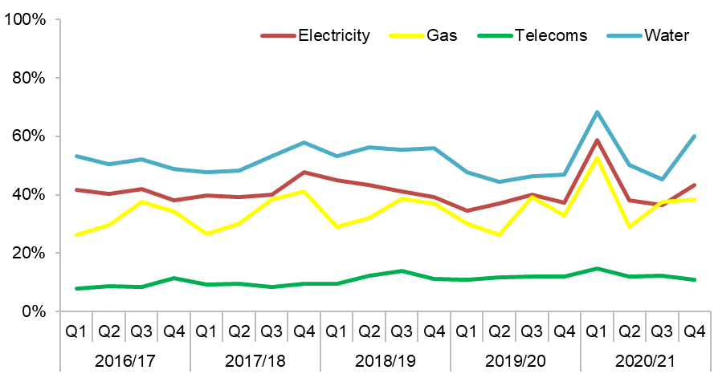

| Period | Electricity | Gas | Other | Telecoms | Water |
| --- | --- | --- | --- | --- | --- |
| 2016/17 Q1 | 41.6% | 26.4% | 4.7% | 7.8% | 53.3% |
| 2016/17 Q2 | 40.3% | 29.6% | 6.4% | 8.6% | 50.5% |
| 2016/17 Q3 | 41.8% | 37.4% | 7.0% | 8.5% | 52.1% |
| 2016/17 Q4 | 38.2% | 34.2% | 3.1% | 11.3% | 48.9% |
| 2017/18 Q1 | 39.8% | 26.6% | 3.7% | 9.4% | 47.7% |
| 2017/18 Q2 | 39.2% | 30.0% | 6.8% | 9.5% | 48.2% |
| 2017/18 Q3 | 39.9% | 38.4% | 3.0% | 8.4% | 53.2% |
| 2017/18 Q4 | 47.8% | 41.2% | 7.5% | 9.7% | 58.0% |
| 2018/19 Q1 | 44.9% | 29.0% | 5.4% | 9.4% | 53.2% |
| 2018/19 Q2 | 43.2% | 32.0% | 6.7% | 12.2% | 56.2% |
| 2018/19 Q3 | 41.2% | 38.6% | 7.8% | 13.9% | 55.5% |
| 2018/19 Q4 | 39.3% | 36.9% | 8.9% | 11.2% | 55.9% |
| 2019/20 Q1 | 34.6% | 30.2% | 3.6% | 10.8% | 47.6% |
| 2019/20 Q2 | 36.9% | 26.3% | 4.2% | 11.9% | 44.5% |
| 2019/20 Q3 | 39.9% | 39.1% | 3.0% | 11.9% | 46.2% |
| 2019/20 Q4 | 37.2% | 32.8% | 3.0% | 11.9% | 47.0% |
| 2020/21 Q1 | 58.6% | 52.7% | 1.5% | 14.8% | 68.3% |
| 2020/21 Q2 | 38.2% | 29.0% | 2.7% | 12.0% | 50.3% |
| 2020/21 Q3 | 36.5% | 37.6% | 2.4% | 12.2% | 45.3% |
| 2020/21 Q4 | 43.2% | 38.5% | 6.7% | 11.0% | 60.1% |

Figure - Utility companies quarterly unplanned works as a % of actual starts

(Source: SRWR Report 9a)

Table 4 provides details of performance for the aggregated Q3/Q4 performance for each of the individual utility companies.

| Organisation | 2020/21 Q3/Q4% | Rating |
| --- | --- | --- |
| Arqiva | 0.0% | Well Managed |
| Axione UK Ltd | 0.0% | Well Managed |
| CenturyLink | 0.0% | Well Managed |
| Commsworld Ltd | 0.0% | Well Managed |
| ES Pipelines Ltd | 0.0% | Well Managed |
| Fulcrum Pipeline Ltd | 0.0% | Well Managed |
| Hyperoptic | 0.0% | Well Managed |
| INEOS FPS | 0.0% | Well Managed |
| Lothian Broadband | 0.0% | Well Managed |
| Sky UK | 0.0% | Well Managed |
| SSE Telecoms | 0.0% | Well Managed |
| Verizon | 0.0% | Well Managed |
| Zayo | 0.0% | Well Managed |
| CityFibre | 0.3% | Well Managed |
| EE | 0.6% | Well Managed |
| Last Mile Electricity Limited | 3.9% | Well Managed |
| Last Mile Gas Limited | 4.2% | Well Managed |
| Network Rail | 4.6% | Well Managed |
| Energy Asset Pipelines | 4.9% | Well Managed |
| Virgin Media Group | 6.2% | Well Managed |
| Murphy Power Distribution Ltd | 6.3% | Well Managed |
| Telefonica UK | 7.1% | Well Managed |
| Royal Mail | 9.1% | Well Managed |
| GTC Pipelines Ltd | 12.6% | Well Managed |
| Vodafone | 14.8% | Well Managed |
| BT | 17.3% | Unsatisfactory |
| SGN | 39.6% | Unsatisfactory |
| SP Energy Networks | 39.8% | Unsatisfactory |
| Scottish & Southern Electricity Networks | 44.7% | Unsatisfactory |
| Scottish Water | 53.3% | Unsatisfactory |

Table - Utility companies unplanned works as a % of actual starts in Q3/Q4

(Source: SRWR Report 9a)

### Roads authority and utility company compliance with directions issued by the SRWC at the onset of the COVID-19 pandemic as a percentage of actual starts

At the onset of the COVID-19 pandemic in March 2020, it was necessary for the Scottish Road Works Commissioner in consultation with the RAUC(s) community to give advice on undertaking road works.

Initially the advice given was that only Emergency, Urgent works should be noticed and commenced whilst ensuring that the safety and wellbeing of those involved in all operations, the general public was a priority.

This direction was later amended to allow essential, (in addition to Emergency, Urgent) works to be progressed which would be detrimental to the wellbeing of society if delayed by 3 months. These works were to be prefaced by the statement “Essential works under COVID-19 guidance” within the works description field.

This indicator compares all active organisation’s compliance with the introduction of the COVID-19 statement as a percentage of their ‘Essential’ works only.

Although the oSRWC has not carried out any analysis to ensure that the nature and essential reasons for individual organisations, progressing unplanned works, a decision was taken to review compliance by organisations to preface their works descriptions.

On reviewing the noticing, it was evident that noticing volumes during the review period for roads authorities had decreased by 25%, whilst utility companies had decreased by less than 1%, compared to the 2019/20 figures.

Compliance with the Scottish Road Works Commissioners directions, was, roads authorities - 72% and utility companies - 85%. Evidence for the below target (>75%) performance by roads authorities has been associated with staff re-deployment and home working protocols.

| Organisation | Compliance | Rating |
| --- | --- | --- |
| Comhairle nan Eilean Siar | 100% | Well Managed |
| Scottish Borders Council | 100% | Well Managed |
| Tay Road Bridge Joint Board | 100% | Well Managed |
| Transport Scotland | 100% | Well Managed |
| Transport Scotland - M77 DBFO | 100% | Well Managed |
| West Dunbartonshire Council | 100% | Well Managed |
| Transport Scotland - M8, M73, M74 DBFO | 94% | Well Managed |
| West Lothian Council | 92% | Well Managed |
| Transport Scotland - M74 DBFO | 91% | Well Managed |
| Clackmannanshire Council | 90% | Well Managed |
| Transport Scotland - NW Unit Op Company | 89% | Well Managed |
| Renfrewshire Council | 87% | Well Managed |
| Fife Council | 87% | Well Managed |
| Transport Scotland - SW Unit Op Company | 86% | Well Managed |
| Falkirk Council | 82% | Well Managed |
| East Ayrshire Council | 78% | Well Managed |
| East Dunbartonshire Council | 77% | Well Managed |
| East Lothian Council | 75% | Well Managed |
| Transport Scotland - NE Unit Op Company | 68% | Satisfactory |
| Transport Scotland - A90 AWPR DBFO | 67% | Satisfactory |
| Transport Scotland - Forth Bridges | 67% | Satisfactory |
| South Ayrshire Council | 63% | Satisfactory |
| Transport Scotland - M80 DBFO | 62% | Satisfactory |
| Angus Council | 62% | Satisfactory |
| Midlothian Council | 62% | Satisfactory |
| Highland Council | 54% | Satisfactory |
| Transport Scotland - SE Unit Op Company | 54% | Satisfactory |
| Aberdeen City Council | 50% | Satisfactory |
| East Renfrewshire Council | 50% | Satisfactory |
| Glasgow City Council | 50% | Unsatisfactory |
| North Ayrshire Council | 50% | Unsatisfactory |
| North Lanarkshire Council | 48% | Unsatisfactory |
| Dumfries & Galloway Council | 45% | Unsatisfactory |
| Perth & Kinross Council | 40% | Unsatisfactory |
| Moray Council | 38% | Unsatisfactory |
| City of Edinburgh Council | 21% | Unsatisfactory |
| Stirling Council | 17% | Unsatisfactory |
| Aberdeenshire Council | 11% | Unsatisfactory |
| Argyll & Bute Council | 11% | Unsatisfactory |
| Dundee City Council | 6% | Unsatisfactory |
| South Lanarkshire Council | 4% | Unsatisfactory |
| Orkney Islands Council | 0% | Unsatisfactory |

Table - Roads authorities compliance with SRWC COVID-19 Directions

(Source: SRWR Data)

| Organisation | Compliance | Rating |
| --- | --- | --- |
| CenturyLink | 100% | Well Managed |
| Last Mile Electricity Ltd. | 100% | Well Managed |
| SSE Telecoms | 100% | Well Managed |
| BT | 93% | Well Managed |
| SGN | 92% | Well Managed |
| Vodafone Limited | 92% | Well Managed |
| GTC Pipelines Limited | 89% | Well Managed |
| Scottish Water | 88% | Well Managed |
| SP Energy Networks | 88% | Well Managed |
| CityFibre | 82% | Well Managed |
| EE | 77% | Well Managed |
| Network Rail | 74% | Satisfactory |
| Virgin Media Group | 61% | Satisfactory |
| Scottish & Southern Electricity Networks | 55% | Satisfactory |
| Telefonica UK | 45% | Unsatisfactory |
| Lothian Broadband | 29% | Unsatisfactory |
| Arqiva | 27% | Unsatisfactory |
| Axione UK Limited | 0% | Unsatisfactory |
| Energy Assets Pipelines | 0% | Unsatisfactory |
| ES Pipelines Limited | 0% | Unsatisfactory |
| Hyperoptic | 0% | Unsatisfactory |
| Verizon | 0% | Unsatisfactory |

Table - Utility companies compliance with SRWC COVID-19 Directions

(Source: SRWR Data)

# Quality of Utility Company Reinstatements

Utility company reinstatements are required to be undertaken in accordance with the Specification for the Reinstatement of Openings in Roads (SROR).

Since 1997, roads authorities across Scotland have undertaken coring of the bituminous bound layers of utility company reinstatements as part of their investigative regime.

In September 2011, RAUC(S) agreed that a minimum acceptable pass rate of 90% should be introduced for all future National Coring Programmes.

A Commissioner Direction was issued to all organisations on 23 January 2012 requiring all utility companies to achieve a pass rate of 90% during all future National Coring Programmes, so far as reasonably practical.

The most recent National Coring Programme sampled and tested reinstatements completed between 1 April 2018 and 31 March 2019. The associated coring report was published in June 2020.

A full copy of the report can be downloaded here:

[National Coring Report 2019-2020 Programme](https://roadworks.scot/publications/national-coring-report-2019-2020-programme)

Recommendations highlighted include:

* full participation by roads authorities;
* another coring programme is required;
* greater focus is required by all undertakers on internal processes and quality control;
* a single contract managed by a lead authority would reduce inconsistencies.

## National Coring Programme 2021

In 2020 RAUC(S) agreed that a further coring programme would be undertaken to investigate the bituminous bound layers in utility company reinstatements completed between 1 January 2021 and 31 December 2021. Advice Note 3 is being updated in advance of the coring activity planned for 2022 and the process agreed by RAUC(S).

## SROR Review

In 2019/20 the Department for Transport (DfT) carried out a review of the Specification for the Reinstatement of openings in Highways (SROH) subsequently publishing the SROH Version 4.

In February 2020 the Scottish Government tasked the SRWC to lead a review and publication of the SROR V5. Funding from the Scottish Government was awarded in March 2020. However, the COVID-19 pandemic has delayed work on the review by approximately 1 year and it is now scheduled for publication in June 2023. In addition the document will include the extended guarantee period for reinstatements from the current 2 years to 6 years for utility company works with a commencement date of October 2023.

# Commissioner Penalties

Section 119A of NRSWA, as amended by the Transport (Scotland) Act 2005, provides powers to the SRWC to impose penalties.

Where the Commissioner is satisfied that a roads authority has failed to comply with duties imposed on them under section 118 of NRWSA, or a utility company has failed to comply with duties imposed on them under section 119 of NRSWA, the SRWC may impose a financial penalty.

## Penalties issued during the reporting period

The Commissioner issued penalties totalling £94,000 to six utility companies in August 2020 following the results of the national coring programme. Full details are available here:

[Six Utility Companies Penalised for Failure to Comply With Scottish Road Works Legislation - 21 August 2020](https://roadworks.scot/publications/six-utility-companies-penalised-failure-comply-scottish-road-works-legislation-21)

## Penalties issued prior to the current reporting period

In the latest five year period, the Scottish Road works Commissioner has issued the following penalties due to individual organisations failing to carry out their duties:

| Year | Amount |
| --- | --- |
| 2016 | £nil |
| 2017 | £35,000 |
| 2018 | £89,000 |
| 2019 | £nil |
| 2020 (to 31 March 2020) | £18,000 |

Table - Commissioner Penalties issued since 2012

Since the office was established in 2008, the SRWC has issued penalties to utility companies and roads authorities totalling £444,000 for failures to comply with their statutory obligations.

# Promotion of Compliance and Good Practice

The promotion of compliance and good practice is key to driving up standards across the road works community.

The committee and working group structure is long established in Scotland and is central to good practice across all road works undertaken.

## Organisational Structure

Roads authorities convene quarterly local co-ordination meetings which utility companies and other interested parties attend. These local meetings inform five area meetings, each of which is represented at RAUC(S).

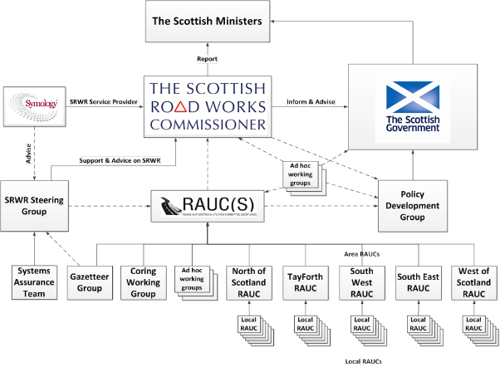

Figure 4 - Scottish road works community structure

The SRWC has the overarching objective of improving the planning, co-ordination and quality of road works in Scotland.

RAUC(S) consists of representatives from both sectors of the road works community and provides support and advice to the SRWC.

In addition to the RAUC(S) committee hierarchy, the road works community is represented on a wide range of working groups in Scotland and across the UK. These working groups inform the development of advice on:

* Legislation
* Codes of Practice
* Advice Notes
* Management and development of the SRWR

Working groups generally report directly to RAUC(S) or, where there are legislative or policy implications, to the Scottish Road Works Policy Development Group (PDG) which is chaired by the Scottish Government.

## Publication of Codes of Practice and Advice

The continued participation of roads authorities and utility companies in the development of guidance ensures that legislation, codes of practice and advice notes are fit for purpose. The Commissioner appreciates the resourcing challenges facing both the public and the private sectors, and continues to encourage organisations to maintain their support and participation in this vital area of work.

The Commissioner would like to take this opportunity to thank those members of the Scottish road works community and their employing organisations for their continued participation and contribution.

The following guidance documents were revised in the reporting period:

* [Code of Practice for Inspections – April 2020](https://roadworks.scot/index.php/legislation-guidance/codes-practice/code-practice-inspections)

Links to this and other publications can be found at the [Legislation & Guidance](https://roadworks.scot/legislationguidance)  section of the Commissioner’s website.

The development of legislation and guidance is an ongoing process and updates will be included in future reports.

Appendix E lists committees and working groups which met during the period of this report. The SRWC was represented at all meetings.

## Technical Standards Monitoring Programme

There has been no physical monitoring during the reporting period due to pandemic restrictions.

## Training and Accreditation Group (TAG)

In 1991 section 126 of NRSWA introduced a requirement for supervisors and operatives to be qualified as prescribed in regulations. In parallel, the first edition of Safety at Street Works and Road Works: A Code of Practice (“the Red Book”) was introduced in 1992.

TAG was established in 2017 to review the qualifications of supervisors and operatives and to develop question banks for use by accredited training providers. The group is co-chaired by a highway authority and a utility company. It consists of representatives from DfT, SRWC, Welsh Government, Northern Ireland RAUC, utility companies, highway authorities and awarding organisations. The Street Works Qualification Register (SWQR) is also represented. This major change to the process for training supervisors and operatives was due to be introduced initially by April 2020 however has been a longer process than anticipated. Good progress has been made in 2020/2021 with regards all new question banks and associated documentation near completion. It is now anticipated that the new question banks and an electronic version of final assessments for candidates be implemented early 2021/2022.

## Safety at Street Works and Road Works : A Code of Practice (2013) – The Red Book

Whilst, the Red Book has been updated several times, most recently in 2013, the associated formal classroom training has remained largely undeveloped. The Transport (Scotland) Act 2019 makes provision that the Red Book will apply to roads authorities, as well as utility companies, working on Scotland’s roads. A review of the Red Book has been discussed in depth during 2020/2021 with a working group review panel to be formed. Going forward this group will start the review during 2021/2022.

# Consultations and Research

The SRWC supports and encourages consultations, research and the promotion of good practice.

This section summarises the involvement of the office during 2020/21. This was obviously affected to some degree by the restrictions on meeting in person and all meetings were held online.

## Scottish Road Research Board (SRRB)

SRRB is a partnership between Transport Scotland, SCOTS and the SRWC.

SRRB commissions research and development to inform improvements in safety, construction, operation and maintenance of the Scottish road network. Objectives include promoting innovation and best practice across roads authorities.

The research programme is jointly funded by Transport Scotland and SCOTS.

## Transport Scotland Pavement Forum (TSPF)

The TSPF was established to promote and develop best practice in the selection and use of paving materials, specifically for use on the Scottish trunk road network. The remit was broadened in 2010 to cover all aspects of road pavement design, construction and maintenance, selection of material types and drainage across both trunk and local road networks.

The SRWC continues to support the work of this group.

## Mobility and Access Committee Scotland (MACS)

The Mobility and Access Committee for Scotland (MACS) was established in 2002 and is an advisory non departmental public body which is constituted to:

* consider matters about the needs of disabled persons in connection with transport that the committee think are appropriate.
* advise the Scottish Ministers about those matters that the committee think are appropriate.

The Commissioner engaged with MACS on several occasions through the reporting period.

## Society of Chief Officers of Transportation in Scotland (SCOTS)

The Society of Chief Officers of Transportation in Scotland (SCOTS) was founded in 1996 following a change in local government. It is a strategic body comprising of transportation professionals from all the 32 councils and the seven regional transport partnerships. The society's work involves improving performance and innovation in the design, delivery and maintenance of transportation systems.

The Commissioner re-established links with SCOTS in the reporting period and is now a regular participant in its Liaison Committee.

# Scottish Road Works Register

Under section 112 of NRSWA, the SRWC has a statutory duty to keep a register of road works. This register is known as the Scottish Road Works Register (SRWR).

## The Scottish Road Works Register

The SRWR is a cloud based register used for the transfer, retention and management of data used for the planning of road works across Scotland. Utility companies and roads authorities operating in Scotland have access to the SRWR and are required to give notice of their proposed road works to others who undertake road works allowing roads authorities to co-ordinate these works. It includes a public facing website to inform the travelling public and others affected by works of potential disruptions. It is funded by the user community through a levy of Prescribed Fees and Amounts which are collected annually by the SRWC.

In summary, the SRWR is:

* the main tool used by roads authorities and utility companies to:
* share information on road works
* assist in the planning and co-ordination of works in roads and
* share the results of inspections carried out for compliance with safety and reinstatement standards
* a source of data for management information to measure the performance of organisations undertaking works in roads and
* a source of information for the public and other interested parties regarding planned, on-going and completed works

During the 2020/21 reporting period, the SRWR was available for over 99% of the contracted core operational time.

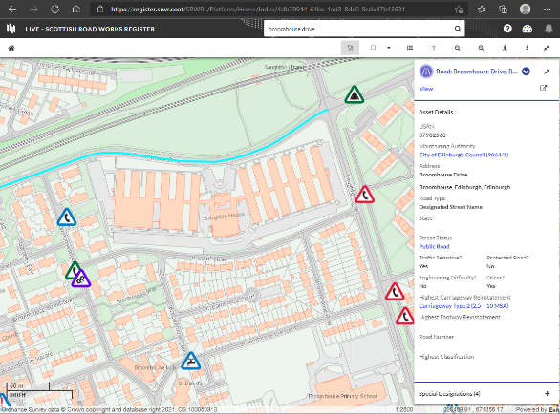

Screenshot of the Scottish Road Works Register.

The average number of named users of the SRWR over the period was 2,960.

| Period | Users |
| --- | --- |
| 2016/17 | 2,186 |
| 2017/18 | 2,088 |
| 2018/19 | 2,117 |
| 2019/20 | 2,387 |
| 2020/21 | 2,960 |

Figure 5 – Number of Named SRWR Users by Year.

The contracted maximum number of concurrent users (those logged into the SRWR at any one time) during 2020/21 was 350.

This reporting period was the third year of the contract for the provision of the SRWR on behalf of the SRWC. The contract has a minimum duration of 4 years with the option to extend for an additional 3 years, in 1 year increments.

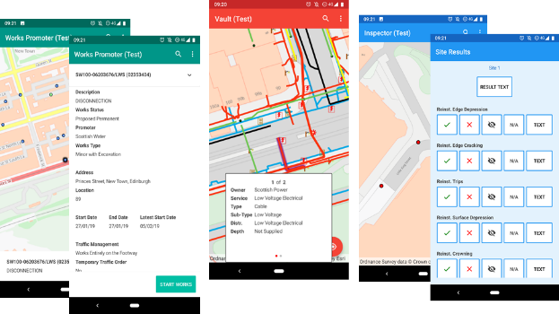

Screenshots of the three SRWR Apps available.

The contract includes a continuous improvement clause requiring the service provider to keep the SRWR compliant with all relevant legislation and regularly provide enhancements to the service. During the reporting period a major overhaul of the software used in the provision of the SRWR was introduced. The new software, named Aurora by the service provider Symology, makes use of a more accessible web based interface and includes many enhancements to the functionality of the SRWR, improving the system for the user community. The new system went live on 13 July 2020. Both the Commissioner and the community lauded the upgrade as a success.

Also included in the SRWR service are:

## Scottish Road Works Online

A cut down version of the SRWR is available on the internet for the travelling public to access information on road works, showing planned and current road works. The site is compatible with a variety of platforms including desktop, tablet and mobile phones.

Scottish Road Works Online can be found here:

[Scottish Road Works Online](https://www.roadworksscotland.org/?vip=7c11c786-c9c2-45fc-b9e6-5389b39e3156)

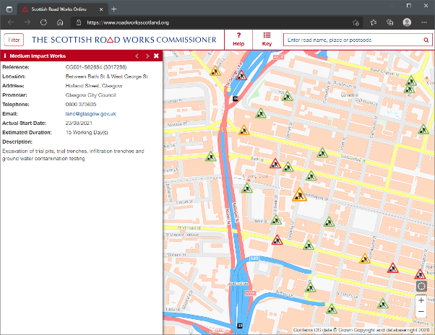

Screenshot from Scottish Road Works Online

## Dial Before You Dig

Whilst the SRWR allows utility companies and roads authorities to exchange details of their apparatus, third parties (those not classed as undertakers or roads authorities) can request information using the Dial Before You Dig Plant Information Request facility offered by the SRWR. This protects operatives carrying out works from harm and protects assets from accidental damage caused by works.

Calls placed to the Dial Before You Dig service are handled by the service provider, Symology, as part of their contractual obligations for the provision of the SRWR. The provider uses the SRWR to pass details of the request to utility companies and roads authorities, who may have apparatus in the affected area. On receipt of a request utility companies and roads authorities are expected to respond with details of affected assets.

On average 123 requests/month were received during 2020/21.

| Year | Requests |
| --- | --- |
| 2016/17 | 2,089 |
| 2017/18 | 2,423 |
| 2018/19 | 2,317 |
| 2019/20 | 1,935 |
| 2020/21 | 1,468 |

Figure 6 – Number of Dial Before You Dig requests processed

Details on this service can be found at:

<http://dialbeforeyoudig.scot> or by calling 08000 231 251

## Community Apparatus Data Vault

RAUC(S) Advice Note 1 – The Sharing of Plant Information requires that records relating to apparatus/plant are made freely available for inspection by any roads authority or utility company. This information is provided using websites showing maps, CDs containing the data, maps by email or printed paper plans sent by post.

The Community Apparatus Data Vault (Vault) is a non-statutory addition to the SRWR introduced in 2011. It is one of the easiest ways available to an organisation to comply with its statutory obligation to share information. Vault displays information from all participating organisations simultaneously on one screen.

Although Vault is a non-statutory facility, it is the opinion of SRWC that its use represents best practice when sharing apparatus/plant information.

## SRWR System Training

With the launch of the new version of the SRWR it was decided to move away from providing training in a classroom environment to an online e-learning platform. This proved to be most fortuitous as this coincided with the first COVID pandemic lockdown. The success of the upgrade to the new system should be accredited in part to the training undertaken by the user community in preparation for the upgrade.

## SRWR Open Data

As part of the new contract for the supply of the SRWR, it is a requirement that road works data recorded on SRWR is made available to download as Open Data. Every transaction relating to works is available for download in a set of CSV (Comma Separated Value) files.

Further information can be found here:

[Scottish Road Works Register Open Data](https://roadworks.scot/publications/scottish-road-works-register-open-data)

## SRWR Steering Group and the System Assurance Team

To ensure that SRWR services are fit for purpose, representatives of the SRWR user community meet regularly as members of the SRWR Steering Group and the System Assurance Team. These meetings are attended by representatives of the software contractor.

This engagement helps ensure that the SRWR continues to serve the needs of roads authorities and utility companies. These groups support both the SRWC and RAUC(S).

## Financing of the Scottish Road Works Register

Provision of the SRWR is funded by the user community through a statutory Prescribed Fees and Amounts levy which is collected annually by the SRWC.

The Parliamentary Regulations supporting the collection of “Fees and Amounts” required for the 2020/21 financial year were:

* The Scottish Road Works Register (Prescribed Fees and Amounts) Regulations 2008 which came into force on 29 February 2008. Whilst the “Fees” element of this legislation has been superseded, the “Amounts” element remains in force.
* The Scottish Road Works Register (Prescribed Fees) Regulations 2020 which came into force on 1 April 2020 prescribes the fee to be collected for 2020/21.

The 2020/21 prescribed fees and amounts collected for the running of the SRWR totalled £911,000. Invoices for the operation of the SRWR were issued to the community on 1 April 2020. Of the 81 invoices issued, 75 were paid before the due date of 1 June 2020. The remaining 6 were all paid by 22 July 2020.

The Scottish Road Works Register (Prescribed Fees) Amendment Regulations 2021 were laid before the Scottish Parliament on 29 January 2021. In conjunction with The Scottish Road Works Register (Prescribed Fees and Amounts) Regulations 2008, these regulations prescribe the £915,000 required to operate the SRWR in 2021/22.

Although the funding for the SRWR varies from year-to-year depending on projected costs, it has remained remarkably stable over the past 5 years, averaging at approximately £840,000 per annum. Given that over 640,000 works have been started in that period, it works out at an overall average cost of around £6.55 for each works started.

# Legislation

The legal framework for road works in Scotland are the New Roads and Street Works Act 1991 (as amended by the Transport (Scotland) Act 2005) and the associated secondary legislation, codes of practice and advice notes. In 2019 this was supplemented by the Transport (Scotland) Act 2019. Part 9 of the 2019 Act makes provisions to enhance the role of the SRWC and to improve the regulation of road works in Scotland.

The Transport (Scotland) Act 2019 received royal ascent in November 2019, and provisions contained in Part 9 will be commenced during the next 3 years.

Reviewing legislation is an ongoing process which most public sector agencies undertake at some time. Reviews can be driven by sector developments, changes in technology/materials, changes in processes or be policy driven and should benefit stakeholders and the public. Consultation is an essential part of any review and a key part of developing legislation.

Links to this legislation and other publications can be found at the [Legislation & Guidance](https://roadworks.scot/legislationguidance)  section of the Commissioner’s website.

## Policy Development Group (PDG)

The road works PDG meets quarterly and is chaired by the Scottish Government. Membership includes representatives from the SRWC, RAUC(S), SCOTS, Street Works UK and the SRWR Steering Group. The group considers amendments to road works policy and provides advice on legislation, codes of practice and advice notes.

## Regulations

The Transport (Scotland) Act 2019 (Commencement No. 3) Regulations 2020 brought into force Section 109 of the Transport (Scotland) Act 2019 (Status of the Scottish Road Works Commissioner) on 14 January 2021.

The Scottish Road Works Register (Prescribed Fees) Regulations 2021 were made on 27 January 2021. These regulations revoked The Scottish Road Works Register (Prescribed Fees) Regulations 2020.

When applied in conjunction with The Scottish Road Works Register (Prescribed Fees and Amounts) Regulations 2008, the 2021 regulations formed the basis for the collection of the 2021/22 Prescribed Fees and Amounts for the operation of the SRWR.

## Legislation and Future Legislation

The SRWC will continue to work closely with Scottish Government with this development and any future legislation.

# Annual Report and Accounts

AZETS Audit Services undertook an external audit of the 2020/21 SRWC Annual Report and Accounts during the summer of 2021.

The Annual Report and Accounts are available to download here:

[Scottish Road Works Commissioner’s Annual Accounts](https://roadworks.scot/publications/annual-accounts)

# Reflection and Forward Planning

## Reflection

There is no doubt that the restrictions and challenges brought by the COVID-19 pandemic affected the planning and execution of road works in Scotland in a way that could never have been foreseen. This resulted in a revised framework for assessing individual organisation performance which aimed to reflect the very challenging circumstances everyone faced.

It is clear that many organisations were able to adjust working practices and by the end of the year had gone some way to returning to levels of work seen prior to the pandemic. This is reflected in the levels of works noticed during the year which only reduced by 6.9% on the previous year. However, it is apparent that the impact of the pandemic affected roads authorities more than it affected undertakers. Roads authorities continued to notice significantly fewer works right through to the end of the reporting period.

The work of the SRWC was impacted mainly in the area of direct engagement with organisations on-site but the rapid adoption of remote working ensured that the core operations of the office continued, albeit at a slightly reduced pace.

The pandemic has significantly delayed the commencement of the road works legislative reforms and the SRWC staff will continue to support the development of these reforms.

The SRWC continued to engage with the wider Scottish road works community, promoting collaborative working between roads authorities and utility companies throughout 2020/21.

The SRWC continued to monitor compliance with road works legislation and good practice guidance over the reporting period.

## Forward Planning

The Business Plan 2021/22, developed in June 2021, is published on the SRWC’s website here ;

[Scottish Road Works Commissioner’s Business Plan 2021-22](https://roadworks.scot/publications/business-plan-2021-22)

In addition to addressing the corporate aims of the office, the plan focuses on the overall governance and objective setting by business area. The plan acknowledges the work to assist Transport Scotland, associated with the progression of the Transport (Scotland) Act 2019.

The 2020-23 Corporate Plan is also published on the SRWC’s website and it is intended that this will be reviewed in the coming year.

[Scottish Road Works Commissioner’s Corporate Plan 2020-23](https://roadworks.scot/publications/corporate-plan-2020-23)

The adoption of new remote working technology through the pandemic could allow the office to move to a hybrid working model which could bring significant benefits for the health and wellbeing of staff whilst reducing the office’s carbon footprint. However, full discussion and consultation with staff will be undertaken before adopting any new working patterns on a permanent basis.

1. List of Acronyms and Terms

The table below proves a list of acronyms and terms used in this report.

| Acronym | Term |
| --- | --- |
| Area RAUC | Area Roads Authorities and Utilities Committee |
| Commissioner | Scottish Road Works Commissioner |
| DBFO | Design, Build, Finance and Operate |
| EI(S)R | Environmental Information (Scotland) Regulations 2004 |
| FOI(S)A | Freedom of Information (Scotland) Act 2002 |
| FPN | Fixed Penalty Notice |
| Gazetteer | List of all roads maintained by a roads authority |
| HAUC (UK) | Highway Authorities and Utilities Committee (UK) |
| Local RAUC | Local Roads Authorities and Utilities Committee |
| NRSWA | New Roads and Street Works Act 1991 |
| PDG | Policy Development Group |
| RAUC(S) | Roads Authorities and Utilities Committee (Scotland) |
| Register | Scottish Road Works Register |
| SCOTS | Society of Chief Officers of Transportation in Scotland |
| SROR | Specification for the Reinstatement of Openings in Roads |
| SRRB | Scottish Road Research Board |
| SRWC | Scottish Road Works Commissioner |
| SRWR | Scottish Road Works Register |
| Utility Company | Those organisations with the statutory powers to place and maintain apparatus in the road. Referred to “undertakers” in NRSWA. |

1. List of Roads Authorities and Utilities

## Roads Authorities

### City Group

Aberdeen City Council

Dundee City Council

City of Edinburgh Council

Glasgow City Council

### Island Group

Comhairle nan Eilean Siar

Orkney Islands Council

Shetland Islands Council

### Rural Group

Aberdeenshire Council

Angus Council

Argyll & Bute Council

Scottish Borders Council

Dumfries & Galloway Council

Highland Council

Perth & Kinross Council

Moray Council

### Semi-Urban Group

East Ayrshire Council

East Lothian Council

Fife Council

Midlothian Council

North Ayrshire Council

South Ayrshire Council

South Lanarkshire Council

Stirling Council

West Lothian Council

### Urban Group

Clackmannanshire Council

East Dunbartonshire Council

East Renfrewshire Council

Falkirk Council

Inverclyde Council

North Lanarkshire Council

Renfrewshire Council

West Dunbartonshire Council

### Trunk Road

Transport Scotland on behalf of Scottish Ministers

### Other

Tay Road Bridge Joint Board

## Utility Companies

### Electricity

ESP Electricity

Fulcrum Electricity Assets Limited

Last Mile Electricity Limited

Murphy Power Distribution Limited

National Grid

Scottish & Southern Electricity Networks (SSEN)

SP Energy Networks (SPEN)

### Gas

Electricity Network company Ltd

Energy Assets Pipelines

ES Pipelines Limited

Fulcrum Pipeline Limited

GTC Pipelines Limited

Last Mile Gas Limited

Murphy Gas Networks Limited

NorthConnect

Premier Transmission Limited

SGN

### Pipelines

BP

CLH Pipelines

EnQuest

INEOS

INEOS FPS

Petroineos Manufacturing Scotland Ltd (PMSL)

Shell

### Telecoms

Arqiva

Axione UK Ltd

Broadband for the Rural North (B4RN)

BT

CityFibre Metro Networks Ltd

CenturyLink

Commsworld Limited

Concept Solutions People Limited (CSP Ltd)

EE

Gamma Telecom

Grain Communications

Hutchison 3G

Hyperoptic

Lothian Broadband

NorthConnect

Sky UK

SSE Telecoms

TalkTalk

Telefonica UK

Verizon

Virgin Media Group

Vodafone Limited

Zayo

### Water

Scottish Water

### Others

Network Rail

Royal Mail

1. Extent of Engagement

Committees and working groups which met during the reporting period at which the SRWC or a representative attended. Due to the pandemic, meetings were held virtually.

| Committees | Frequency | Reports to |
| --- | --- | --- |
| Highway Authorities and Utilities Committee (UK) | 3 per year | N/A |
| Roads Authorities and Utilities Committee (Scotland) | Quarterly | N/A |
| Area RAUC | Quarterly | RAUC(S) |
| Local RAUC | Quarterly | Area RAUCs |

| Working Groups | Frequency | Reports to |
| --- | --- | --- |
| Policy Development Group | Quarterly | Scottish Government |
| Specification for the Reinstatement of Openings in Roads Working Group | When required | RAUC(S) |
| SRWR Steering Group | Quarterly | SRWC/RAUC(S) |
| RAUC(S) Gazetteer Working Group | Quarterly | RAUC(S) |
| System Assurance Team | Quarterly | SRWR Steering Group |
| SRWR Reporting Group | When Required | SRWR Steering Group |
| Code of Practice for Inspections Working Group | When Required | RAUC(S) |
| Training and Accreditation Group (UK) | Quarterly | HAUC (UK) |

In addition to the above specific groups, the following summarises other engagements undertaken during the reporting period by the SRWC during 2020/21.

| Meeting/Engagement | Frequency/Summary |
| --- | --- |
| Utility company specific meetings | Meetings include the promotion of good practice, compliance and enforcement. |
| Roads authority specific meetings | Meetings include the promotion of good practice, compliance and enforcement. |
| Scottish Government | Specialist technical policy groups to assist in the progress of specialist policies and directives.  Input into significant national events.  Liaison meetings as required. |
| Continued professional development | Staff development and knowledge exchange to ensure good practice within the industry. |
| SRWR contract meetings | Quarterly liaison meetings with the software provider. |

1. Additional Indicator Reports

The following summarises the yearly data for information only:

| Trend | Figure(s) |
| --- | --- |
| Roads authority noticing failures as a percentage of actual starts | Table 8 |
| Utility company noticing failures as a percentage of actual starts | Table 9 |
| Early starts as a percentage of actual starts | Figure 7 |
| Late starts as a percentage of actual starts | Figure 8 |
| Works extensions as a percentage of actual starts | Figure 9 |
| Overrunning works as a percentage of actual starts | Figure 10 |
| Works awaiting closure and/or registration of final site reinstatement details, presented as a number | Figure 11 and Figure 12 |
| Sample inspections undertaken by roads authorities in 2020-21 | Figure **13** |
| Sample inspections pass rates undertaken by utility companies in 2020-21 | Figure 14 |
| Substandard traffic management from inspection results | Figure 15 |
| Roads authorities and utility companies registering works with missing contact details as percentage of actual starts | Figure 16 |
| Roads authorities and utility companies registering works with traffic management type “not yet known”, as a percentage of actual starts | Figure 17 |
| Actual and potential fixed penalty notices (FPNs) issued to utility companies as a percentage of actual starts | Figure 18 |
| Undue delay (S125) notices issued by roads authorities and received by utility companies | Table 10 |
| Average works per 100km for authorities in each SCOTS group and Transport Scotland | Figure 19 |

## Roads authority and utility company noticing failures as a percentage of actual starts

All qualifying road works carried out by utility companies and roads authorities are required to be registered (noticed) on the Scottish Road Works Register (SRWR).

Utility company noticing failures are system generated by the SRWR and referred to as potential noticing offences. Each potential noticing offence is reviewed by a roads authority and may attract a Fixed Penalty Notice (FPN) (not all roads authorities have taken up the option to issue FPNs).

Roads authority noticing failures are also system generated by the SRWR and referred to as potential noticing failures for comparison purposes with utility company performance. They are not subject to FPNs as an authority cannot issue a penalty against themselves.

This indicator compares the average noticing failure rate of all utility companies against the average noticing failure rate of all roads authorities and the individual failure rates of utility companies and roads authorities.

Notices required to be registered on the SRWR include:

* Advance Notice (NRSWA Section 113(5))
* Start Notice (NRSWA Section 114(5))
* Emergency Notice (NRSWA Section 116(4))
* Works Closed Notice (NRSWA Section 129(6))

It is expected that all roads authorities and utility companies achieve a failure rate of 4% or less, as noticing of road works is an administrative function.

| Roads Authorities | 2016/17 | 2017/18 | 2018/19 | 2019/20 | 2020/21 |
| --- | --- | --- | --- | --- | --- |
| Aberdeen City Council | 30.8% | 26.3% | 7.0% | 3.9% | 5.5% |
| Aberdeenshire Council | 11.8% | 6.1% | 13.1% | 4.0% | 6.9% |
| Angus Council | 3.1% | 22.7% | 4.3% | 1.2% | 3.4% |
| Argyll & Bute Council | 4.8% | 2.6% | 2.6% | 5.8% | 13.7% |
| City of Edinburgh Council | 24.0% | 21.6% | 21.1% | 7.8% | 9.4% |
| Clackmannanshire Council | 2.6% | 4.6% | 2.3% | 0.6% | 6.1% |
| Comhairle nan Eilean Siar | 1.6% | 2.1% | 1.7% | 0.8% | 1.0% |
| Dumfries & Galloway Council | 15.0% | 13.3% | 3.7% | 2.5% | 12.0% |
| Dundee City Council | 22.4% | 13.7% | 15.3% | 14.6% | 17.6% |
| East Ayrshire Council | 13.2% | 7.5% | 11.6% | 16.7% | 10.5% |
| East Dunbartonshire Council | 2.5% | 1.6% | 2.5% | 1.6% | 2.5% |
| East Lothian Council | 6.7% | 8.3% | 5.3% | 10.1% | 19.7% |
| East Renfrewshire Council | 21.5% | 12.4% | 18.4% | 10.0% | 5.6% |
| Falkirk Council | 3.5% | 5.3% | 4.7% | 4.2% | 6.8% |
| Fife Council | 15.5% | 19.2% | 8.6% | 2.9% | 6.9% |
| Glasgow City Council | 5.2% | 9.2% | 6.7% | 4.1% | 17.9% |
| Highland Council | 21.7% | 11.4% | 10.0% | 7.8% | 11.4% |
| Inverclyde Council | 2.2% | 1.8% | 3.0% | 1.7% | 1.4% |
| Midlothian Council | 3.8% | 8.0% | 1.9% | 0.6% | 4.0% |
| Moray Council | 3.3% | 3.3% | 0.5% | 2.5% | 12.1% |
| North Ayrshire Council | 10.1% | 3.3% | 8.3% | 2.8% | 15.2% |
| North Lanarkshire Council | 23.7% | 9.6% | 4.4% | 1.9% | 3.8% |
| Orkney Islands Council | 15.6% | 21.6% | 7.1% | 8.7% | 21.5% |
| Perth & Kinross Council | 19.0% | 7.4% | 4.4% | 1.2% | 3.0% |
| Renfrewshire Council | 0.7% | 1.4% | 1.1% | 0.9% | 3.7% |
| Scottish Borders Council | 8.8% | 14.0% | 8.0% | 3.2% | 7.3% |
| Shetland Islands Council | 1.8% | 2.1% | 2.5% | 4.3% | 10.4% |
| South Ayrshire Council | 10.0% | 5.8% | 6.3% | 6.3% | 5.8% |
| South Lanarkshire Council | 7.6% | 9.2% | 5.0% | 2.6% | 6.1% |
| Stirling Council | 3.2% | 6.5% | 4.3% | 4.6% | 14.8% |
| Tay Road Bridge Joint Board | N/A | 0.0% | 0.0% | 9.1% | 200.0% |
| Transport Scotland | 5.5% | 6.5% | 3.9% | 3.1% | 3.1% |
| West Dunbartonshire Council | 11.0% | 9.7% | 70.7% | 35.8% | 5.2% |
| West Lothian Council | 13.0% | 12.9% | 4.7% | 3.0% | 4.3% |

Note: N/A indicates the organisation did not undertake any works in that year.

Table - Roads authority noticing failures as a percentage of actual starts

(Source: SRWR Report 2a and SRWR Report 9a)

| Organisation | 2016/17 | 2017/18 | 2018/19 | 2019/20 | 2020/21 |
| --- | --- | --- | --- | --- | --- |
| Arqiva | 4.0% | 6.1% | 14.2% | 2.9% | 0.0% |
| Axione UK Limited | N/A | N/A | N/A | 0.0% | 7.1% |
| Broadband for the Rural North Limited | 0.0% | 100.0% | N/A | N/A | N/A |
| BT | 11.2% | 7.9% | 4.3% | 3.4% | 3.7% |
| CenturyLink | 33.3% | 0.0% | 20.0% | 17.6% | 50.0% |
| CityFibre | 28.0% | 9.1% | 6.1% | 6.1% | 5.6% |
| Commsworld Limited | N/A | N/A | N/A | N/A | 0.0% |
| Concept Solutions People | 8.7% | 0.0% | 30.0% | 66.7% | N/A |
| EE | 8.7% | 6.2% | 9.5% | 3.5% | 5.6% |
| Energy Assets Pipelines | 75.0% | 83.3% | 13.6% | 16.3% | 14.9% |
| ES Pipelines Limited | 27.8% | 15.2% | 8.3% | 9.2% | 50.8% |
| ESP Electricity | N/A | N/A | 0.0% | N/A | N/A |
| Fulcrum Pipeline Limited | 29.8% | 124.5% | 55.3% | 67.7% | 46.2% |
| GTC Pipelines Limited | 15.5% | 27.3% | 24.0% | 24.6% | 7.9% |
| Hyperoptic | N/A | 0.0% | 4.5% | 20.0% | 17.0% |
| INEOS FPS | N/A | 100.0% | 25.0% | N/A | 0.0% |
| INEOS O & P UK | 100.0% | 50.0% | N/A | N/A | N/A |
| Last Mile Electricity Limited | 11.1% | 14.5% | 30.6% | 16.2% | 8.8% |
| Last Mile Gas Limited | N/A | N/A | N/A | N/A | 4.2% |
| Lothian Broadband | N/A | N/A | N/A | 0.0% | 0.0% |
| Murphy Gas Networks Limited | N/A | N/A | N/A | N/A | 100.0% |
| Murphy Power Distribution Limited | N/A | N/A | N/A | N/A | 65.4% |
| National Grid | 100.0% | 0.0% | 10.5% | N/A | N/A |
| Network Rail | 3.2% | 10.9% | 6.1% | 2.0% | 3.9% |
| Petroineos Manufacturing Scotland Ltd | N/A | N/A | N/A | 66.7% | N/A |
| Royal Mail | 44.4% | 14.5% | 25.3% | 4.1% | 25.3% |
| Scottish & Southern Electricity Networks | 5.3% | 5.6% | 4.7% | 13.5% | 8.2% |
| Scottish Water | 4.1% | 3.7% | 3.1% | 3.1% | 3.4% |
| SGN | 5.2% | 8.7% | 7.3% | 5.6% | 7.9% |
| Sky UK | 133.3% | N/A | 58.3% | 0.0% | 0.0% |
| SP Energy Networks | 5.7% | 7.1% | 7.1% | 6.2% | 5.8% |
| SSE Telecoms | 11.2% | 2.3% | 1.6% | 3.2% | 7.4% |
| Telefonica UK | 16.1% | 11.5% | 6.2% | 5.3% | 11.6% |
| Verizon | 48.5% | 47.6% | 22.2% | 0.0% | 50.0% |
| Virgin Media | 8.2% | 8.5% | 8.1% | 6.9% | 13.6% |
| Vodafone | 18.7% | 8.3% | 6.0% | 3.2% | 4.1% |
| Zayo | 20.0% | 7.1% | 72.7% | 50.0% | 20.0% |

Note: N/A indicates the organisation did not undertake any works in that year.

Table - Utility company noticing failures as a percentage of actual starts

(Source: SRWR Report 2b and SRWR Report 9a)

## Early and late starts as a percentage of actual starts

This indicator records the percentage of works with a registered start date in the SRWR where an early or late start request has subsequently been made.

Early starts with the agreement of utility companies and roads authorities can be a sign of good co-ordination. Where a window of opportunity exists to undertake works, it should be considered. Excessive use suggests poor works planning.

| Period | Roads Authorities | Utility Companies |
| --- | --- | --- |
| 2016/17 Q1 | 24.0% | 10.0% |
| 2016/17 Q2 | 25.0% | 9.0% |
| 2016/17 Q3 | 23.0% | 10.0% |
| 2016/17 Q4 | 27.0% | 13.0% |
| 2017/18 Q1 | 17.3% | 10.0% |
| 2017/18 Q2 | 12.9% | 9.4% |
| 2017/18 Q3 | 14.8% | 7.6% |
| 2017/18 Q4 | 21.5% | 6.5% |
| 2018/19 Q1 | 18.0% | 6.7% |
| 2018/19 Q2 | 16.4% | 7.4% |
| 2018/19 Q3 | 14.0% | 7.5% |
| 2018/19 Q4 | 16.3% | 8.5% |
| 2019/20 Q1 | 15.2% | 9.0% |
| 2019/20 Q2 | 11.2% | 7.7% |
| 2019/20 Q3 | 9.8% | 9.2% |
| 2019/20 Q4 | 12.9% | 9.5% |
| 2020/21 Q1 | 15.1% | 10.2% |
| 2020/21 Q2 | 14.5% | 9.7% |
| 2020/21 Q3 | 11.3% | 9.1% |
| 2020/21 Q4 | 13.5% | 7.4% |

Figure - Early starts as a percentage of actual starts

(Source: SRWR Report 10 and SRWR Report 9a)

| Period | Roads Authorities | Utility Companies |
| --- | --- | --- |
| 2016/17 Q1 | 1.7% | 0.8% |
| 2016/17 Q2 | 1.5% | 0.8% |
| 2016/17 Q3 | 1.7% | 0.8% |
| 2016/17 Q4 | 1.6% | 0.9% |
| 2017/18 Q1 | 1.2% | 0.7% |
| 2017/18 Q2 | 2.2% | 0.7% |
| 2017/18 Q3 | 1.2% | 0.8% |
| 2017/18 Q4 | 2.7% | 0.8% |
| 2018/19 Q1 | 1.4% | 0.6% |
| 2018/19 Q2 | 1.1% | 0.5% |
| 2018/19 Q3 | 1.0% | 0.6% |
| 2018/19 Q4 | 1.1% | 0.5% |
| 2019/20 Q1 | 1.0% | 0.7% |
| 2019/20 Q2 | 0.7% | 0.5% |
| 2019/20 Q3 | 0.6% | 0.5% |
| 2019/20 Q4 | 0.8% | 0.6% |
| 2020/21 Q1 | 1.4% | 0.7% |
| 2020/21 Q2 | 1.1% | 1.2% |
| 2020/21 Q3 | 1.9% | 0.4% |
| 2020/21 Q4 | 1.8% | 0.4% |

Figure - Late starts as a percentage of actual starts

(Source: SRWR Report 10 and SRWR Report 9a)

## Work extensions as a percentage of actual starts

Works extensions are granted to a utility company with the agreement of the affected roads authority when an expected completion date is unlikely to be achieved.

This indicator compares the percentage of utility company road works and roads authority works which have been extended beyond their expected end date.

| Period | Roads Authorities | Utility Companies |
| --- | --- | --- |
| 2016/17 Q1 | 16.0% | 9.0% |
| 2016/17 Q2 | 14.0% | 9.0% |
| 2016/17 Q3 | 19.0% | 9.0% |
| 2016/17 Q4 | 17.0% | 9.0% |
| 2017/18 Q1 | 12.0% | 8.0% |
| 2017/18 Q2 | 13.0% | 8.0% |
| 2017/18 Q3 | 14.0% | 8.0% |
| 2017/18 Q4 | 18.0% | 9.0% |
| 2018/19 Q1 | 10.7% | 7.7% |
| 2018/19 Q2 | 11.8% | 7.7% |
| 2018/19 Q3 | 9.5% | 9.4% |
| 2018/19 Q4 | 7.9% | 6.7% |
| 2019/20 Q1 | 6.2% | 6.9% |
| 2019/20 Q2 | 6.9% | 7.3% |
| 2019/20 Q3 | 7.7% | 6.5% |
| 2019/20 Q4 | 7.6% | 7.2% |
| 2020/21 Q1 | 5.9% | 7.9% |
| 2020/21 Q2 | 7.4% | 7.0% |
| 2020/21 Q3 | 9.8% | 7.6% |
| 2020/21 Q4 | 9.7% | 10.4% |

Figure - Works extensions as a percentage of actual starts

(Source: SRWR Report 12 and SRWR Report 9a)

## Overrunning works as a percentage of planned works

Works overruns occur when a road works completion date goes beyond the expected end date recorded in the Scottish Road Works Register (SRWR).

The term “planned works” include major, standard and minor works registered on the SRWR.

| Period | Roads Authorities | Utility Companies |
| --- | --- | --- |
| 2016/17 Q1 | 3.1% | 2.0% |
| 2016/17 Q2 | 2.7% | 2.3% |
| 2016/17 Q3 | 2.5% | 2.6% |
| 2016/17 Q4 | 1.5% | 2.2% |
| 2017/18 Q1 | 1.0% | 3.0% |
| 2017/18 Q2 | 1.3% | 4.4% |
| 2017/18 Q3 | 0.9% | 6.0% |
| 2017/18 Q4 | 1.0% | 3.2% |
| 2018/19 Q1 | 0.9% | 1.8% |
| 2018/19 Q2 | 0.9% | 1.7% |
| 2018/19 Q3 | 0.8% | 2.0% |
| 2018/19 Q4 | 0.7% | 1.6% |
| 2019/20 Q1 | 0.3% | 2.3% |
| 2019/20 Q2 | 0.3% | 2.2% |
| 2019/20 Q3 | 0.7% | 3.0% |
| 2019/20 Q4 | 0.4% | 2.1% |
| 2020/21 Q1 | 0.5% | 1.9% |
| 2020/21 Q2 | 0.4% | 2.9% |
| 2020/21 Q3 | 0.4% | 2.3% |
| 2020/21 Q4 | 0.3% | 1.8% |

Figure - Overrunning works as a percentage of planned works

(Source: SRWR Report 6 and SRWR Report 9a)

## Works awaiting closure and/or registration of final site reinstatement details as a percentage of actual starts

On completion of road works on site, utility companies are required to place a “works closed” notice in the SRWR by 16:30 the following day. This is followed by a “final site reinstatement details” notice within 5 days.

On completion of road works on site, roads authorities are required to place a “works closed” notice in the SRWR by 16:30 the following day. There is no requirement to record site reinstatement details.

This report compares utility company failures to place “works closed” notices against roads authority failures to place “works closed” notices.

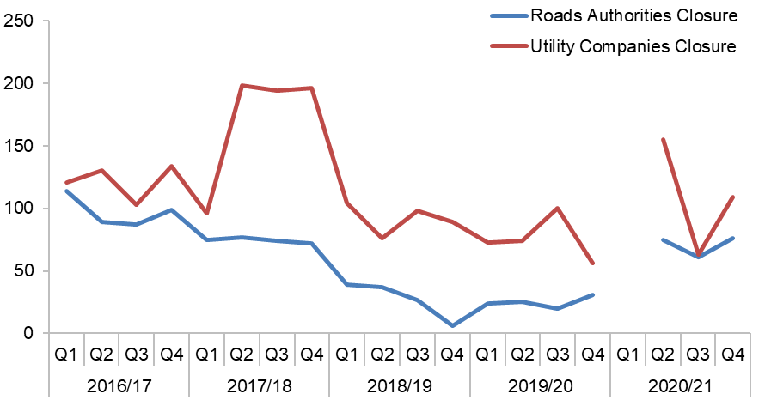

Note: 2020/21 Q1 figures were incorrectly inflated due to problems with SRWR migration to Aurora, incorrect figures removed.

| Period | Roads Authorities | Utility Companies |
| --- | --- | --- |
| 2016/17 Q1 | 114 | 121 |
| 2016/17 Q2 | 89 | 130 |
| 2016/17 Q3 | 87 | 103 |
| 2016/17 Q4 | 99 | 134 |
| 2017/18 Q1 | 75 | 96 |
| 2017/18 Q2 | 77 | 198 |
| 2017/18 Q3 | 74 | 194 |
| 2017/18 Q4 | 72 | 196 |
| 2018/19 Q1 | 39 | 104 |
| 2018/19 Q2 | 37 | 76 |
| 2018/19 Q3 | 27 | 98 |
| 2018/19 Q4 | 6 | 89 |
| 2019/20 Q1 | 24 | 73 |
| 2019/20 Q2 | 25 | 74 |
| 2019/20 Q3 | 20 | 100 |
| 2019/20 Q4 | 31 | 56 |
| 2020/21 Q1 | Removed | Removed |
| 2020/21 Q2 | 75 | 155 |
| 2020/21 Q3 | 61 | 63 |
| 2020/21 Q4 | 76 | 109 |

Figure - Works awaiting closure as a number

(Source: SRWR Report 16)

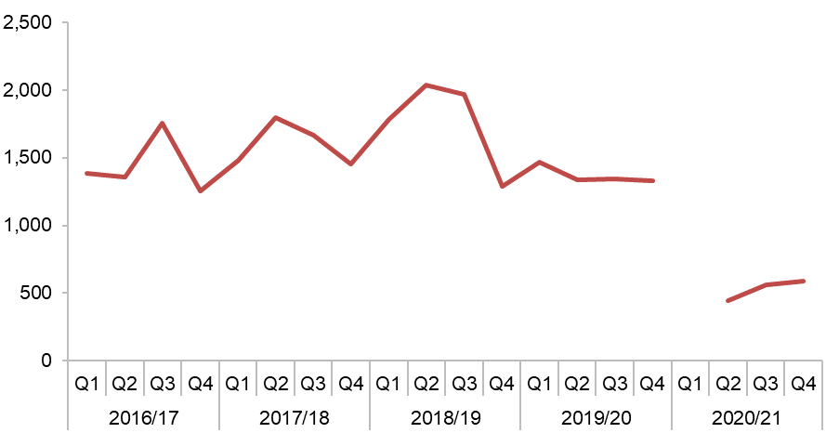

Note: 2020/21 Q1 figures were incorrectly inflated due to problems with SRWR migration to Aurora, incorrect figures removed.

| Period | Utility Companies |
| --- | --- |
| 2016/17 Q1 | 1,382 |
| 2016/17 Q2 | 1,359 |
| 2016/17 Q3 | 1,752 |
| 2016/17 Q4 | 1,252 |
| 2017/18 Q1 | 1,478 |
| 2017/18 Q2 | 1,796 |
| 2017/18 Q3 | 1,663 |
| 2017/18 Q4 | 1,456 |
| 2018/19 Q1 | 1,782 |
| 2018/19 Q2 | 2,038 |
| 2018/19 Q3 | 1,971 |
| 2018/19 Q4 | 1,287 |
| 2019/20 Q1 | 1,465 |
| 2019/20 Q2 | 1,335 |
| 2019/20 Q3 | 1,341 |
| 2019/20 Q4 | 1,329 |
| 2020/21 Q1 | Removed |
| 2020/21 Q2 | 443 |
| 2020/21 Q3 | 562 |
| 2020/21 Q4 | 591 |

Figure - Works awaiting registration of final site reinstatement details as a number

(Source: SRWR Report 16)

## Sample inspections undertaken by roads authorities and utility company failure rate

Sample inspections are undertaken on a 30% randomly generated sample of utility company road works. Inspections are carried out at various stages during the works and the reinstatement guarantee period. These inspections are carried out by roads authorities.

Sample Inspections carried out by roads authorities consist of:

### Category A (10% sample) – Undertaken while works are in progress.

Inspections check that works are carried out safely and that signs, barriers, safety zones, compaction, layer depth, etc., comply with Safety at Street Works and Road Works : A Code of Practice (commonly known as “The Red Book”) and the Specification for the Reinstatement for Openings in Roads (SROR).

### Category B (10% sample) – Undertaken within the six month period following interim or permanent reinstatement.

Inspections check that works are completed to the proper standards. Checking for items, such as edge depression, crowning, etc., in accordance with the SROR.

### Category C (10% sample) – Undertaken within the three month period preceding the end of the guarantee period.

Inspections again check that works are constructed to the proper standards in accordance with the SROR. Greater focus is given to settlement, cracking and joint failure following trafficking.

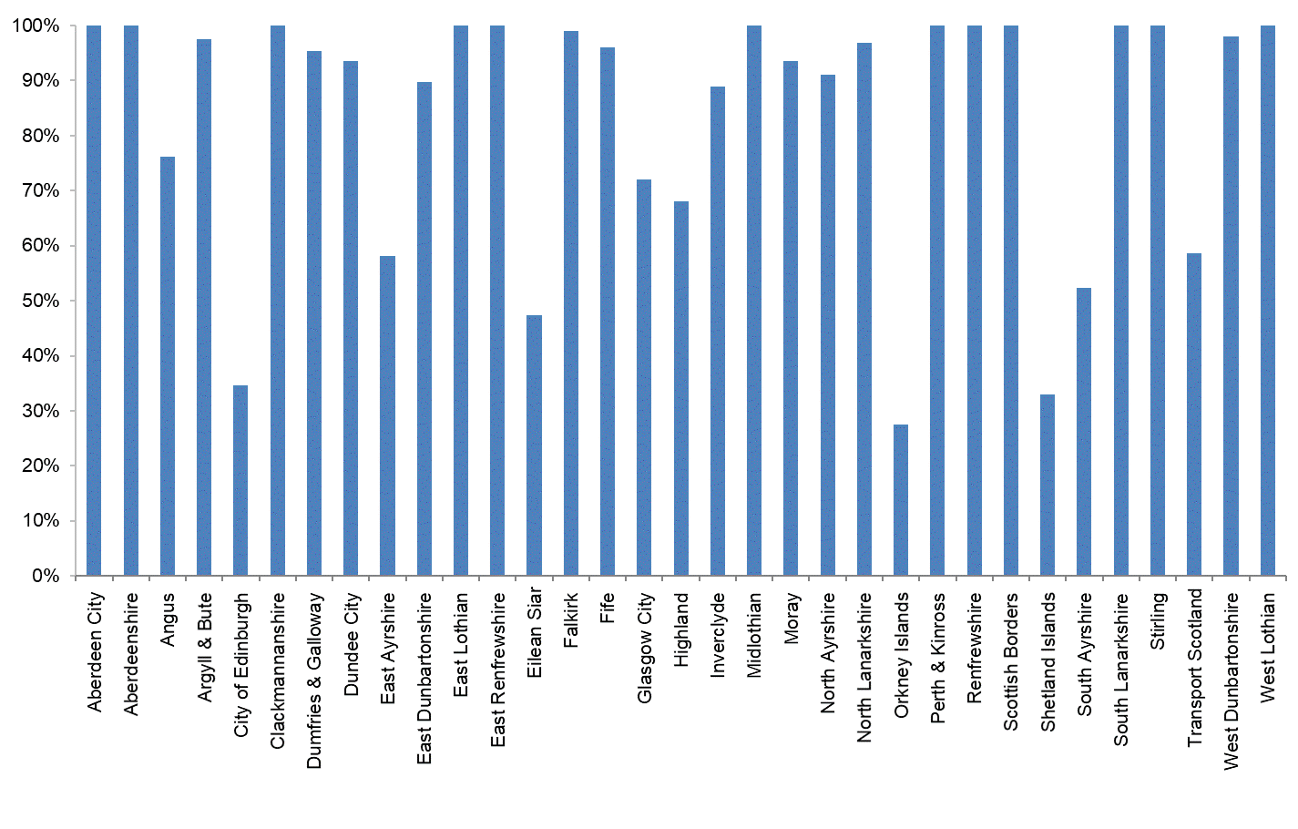

| Authority | Inspections  Done | Sample  Size | Sample %  Done |
| --- | --- | --- | --- |
| Aberdeen City Council | 886 | 861 | 102.9% |
| Aberdeenshire Council | 861 | 845 | 101.9% |
| Angus Council | 282 | 370 | 76.2% |
| Argyll & Bute Council | 408 | 418 | 97.6% |
| City of Edinburgh Council | 803 | 2314 | 34.7% |
| Clackmannanshire Council | 192 | 188 | 102.1% |
| Comhairle nan Eilean Siar | 92 | 194 | 47.4% |
| Dumfries & Galloway Council | 695 | 729 | 95.3% |
| Dundee City Council | 502 | 537 | 93.5% |
| East Ayrshire Council | 329 | 566 | 58.1% |
| East Dunbartonshire Council | 367 | 409 | 89.7% |
| East Lothian Council | 515 | 483 | 106.6% |
| East Renfrewshire Council | 405 | 399 | 101.5% |
| Falkirk Council | 606 | 612 | 99.0% |
| Fife Council | 1,440 | 1,499 | 96.1% |
| Glasgow City Council | 1,819 | 2,524 | 72.1% |
| Highland Council | 620 | 910 | 68.1% |
| Inverclyde Council | 273 | 307 | 88.9% |
| Midlothian Council | 434 | 408 | 106.4% |
| Moray Council | 333 | 356 | 93.5% |
| North Ayrshire Council | 397 | 436 | 91.1% |
| North Lanarkshire Council | 1,283 | 1,324 | 96.9% |
| Orkney Islands Council | 33 | 120 | 27.5% |
| Perth & Kinross Council | 621 | 574 | 108.2% |
| Renfrewshire Council | 706 | 705 | 100.1% |
| Scottish Borders Council | 537 | 495 | 108.5% |
| Shetland Islands Council | 35 | 106 | 33.0% |
| South Ayrshire Council | 272 | 520 | 52.3% |
| South Lanarkshire Council | 1,432 | 1,346 | 106.4% |
| Stirling Council | 638 | 609 | 104.8% |
| Tay Road Bridge Joint Board | N/A | N/A | N/A |
| Transport Scotland | 211 | 360 | 58.6% |
| West Dunbartonshire Council | 286 | 292 | 97.9% |
| West Lothian Council | 798 | 740 | 107.8% |

Figure 13 - Sample inspections undertaken by roads authorities in 2020-21

(Source: SRWR Quarterly Inspection Report and SRWR Inspections Statistics)

When a utility company fails in excess of 10% of their sample inspections, under the Code of Practice for Inspections, a roads authority may require a utility company to follow an improvement plan process.

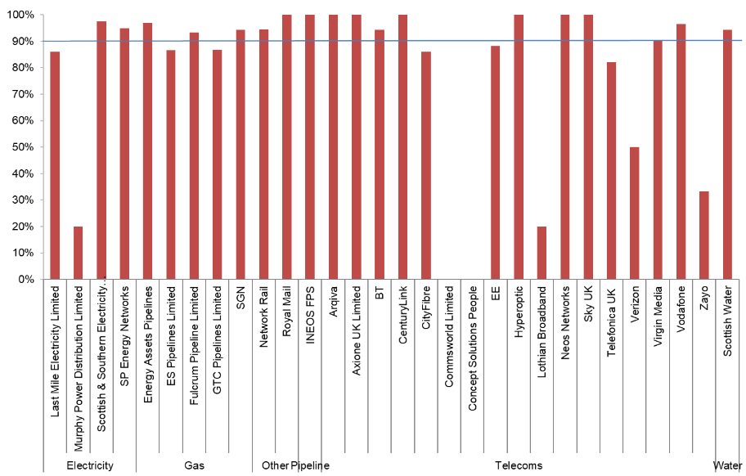

| Undertaker Type | Organisation | Passed | Inspected | Pass % |
| --- | --- | --- | --- | --- |
| Electricity | Last Mile Electricity Limited | 80 | 93 | 86.0% |
| Electricity | Murphy Power Distribution Limited | 1 | 5 | 20.0% |
| Electricity | Scottish & Southern Electricity Networks | 456 | 468 | 97.4% |
| Electricity | SP Energy Networks | 2,100 | 2,215 | 94.8% |
| Gas | Energy Assets Pipelines | 30 | 31 | 96.8% |
| Gas | ES Pipelines Limited | 39 | 45 | 86.7% |
| Gas | Fulcrum Pipeline Limited | 14 | 15 | 93.3% |
| Gas | GTC Pipelines Limited | 59 | 68 | 86.8% |
| Gas | SGN | 2,450 | 2,598 | 94.3% |
| Other | Network Rail | 34 | 36 | 94.4% |
| Other | Royal Mail | 23 | 23 | 100.0% |
| Pipeline | INEOS FPS | 2 | 2 | 100.0% |
| Telecoms | Arqiva | 16 | 16 | 100.0% |
| Telecoms | Axione UK Limited | 1 | 1 | 100.0% |
| Telecoms | BT | 3,655 | 3,876 | 94.3% |
| Telecoms | CenturyLink | 1 | 1 | 100.0% |
| Telecoms | CityFibre | 741 | 861 | 86.1% |
| Telecoms | Commsworld Limited | 0 | 1 | 0.0% |
| Telecoms | Concept Solutions People | 0 | 1 | 0.0% |
| Telecoms | EE | 37 | 42 | 88.1% |
| Telecoms | Hyperoptic | 7 | 7 | 100.0% |
| Telecoms | Lothian Broadband | 1 | 5 | 20.0% |
| Telecoms | Neos Networks | 23 | 23 | 100.0% |
| Telecoms | Sky UK | 1 | 1 | 100.0% |
| Telecoms | Telefonica UK | 23 | 28 | 82.1% |
| Telecoms | Verizon | 1 | 2 | 50.0% |
| Telecoms | Virgin Media | 2,073 | 2,294 | 90.4% |
| Telecoms | Vodafone | 54 | 56 | 96.4% |
| Telecoms | Zayo | 1 | 3 | 33.3% |
| Water | Scottish Water | 5,941 | 6,294 | 94.4% |

Figure -Sample inspection pass rates undertaken by utility companies in 2020-21

(Source: SRWR Quarterly Inspection Report and SRWR Inspections Statistics)

## Substandard traffic management from inspection results

This indicator considers the number of substandard traffic management layouts recorded during roads authority inspections of utility company road works.

In addition to sample inspections, roads authorities also carry out inspections at their discretion. These inspections include routine inspections, inspections relating to a previously identified defect, inspections following a third party report and inspections following notification of a defective reinstatement. This report shows the total number of inspection results which failed, showing substandard traffic management as the reason for failure.

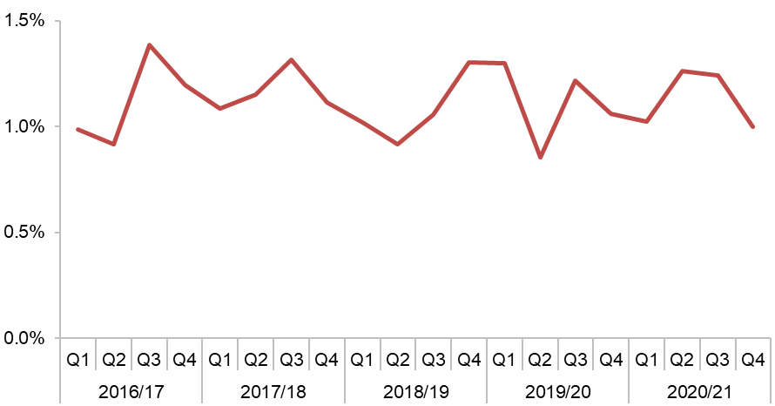

| Period | Substandard TM % |
| --- | --- |
| 2016/17 Q1 | 1.0% |
| 2016/17 Q2 | 0.9% |
| 2016/17 Q3 | 1.4% |
| 2016/17 Q4 | 1.2% |
| 2017/18 Q1 | 1.1% |
| 2017/18 Q2 | 1.2% |
| 2017/18 Q3 | 1.3% |
| 2017/18 Q4 | 1.1% |
| 2018/19 Q1 | 1.0% |
| 2018/19 Q2 | 0.9% |
| 2018/19 Q3 | 1.1% |
| 2018/19 Q4 | 1.3% |
| 2019/20 Q1 | 1.3% |
| 2019/20 Q2 | 0.9% |
| 2019/20 Q3 | 1.2% |
| 2019/20 Q4 | 1.1% |
| 2020/21 Q1 | 1.0% |
| 2020/21 Q2 | 1.3% |
| 2020/21 Q3 | 1.2% |
| 2020/21 Q4 | 1.0% |

Figure - Substandard traffic management from inspection results

(Source: SRWR Report 19 and SRWR Report 9a)

## Works registered with missing contact details

Organisations are required to provide contact details of the contractor carrying out road works and details of the person registering the works on the Scottish Road Works Register (SRWR).

Each road works notice recorded in the SRWR must include the originator name, the originator telephone number, the contractor name and the contractor telephone number. At the very latest, these four fields must be populated when works reach the “in progress” phase. For example when an actual start notice is registered for a works.

Contact details entered in the SRWR by roads authorities and utility companies undertaking road works are expected to be accurate. This information is required for co-ordination and co-operation.

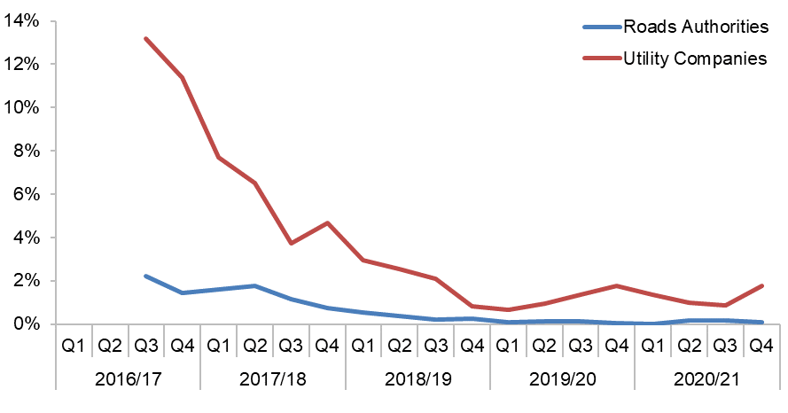

Note: Data for this metric was not collected before 2016/17 Q3.

| Period | Roads Authorities | Utility Companies |
| --- | --- | --- |
| 2016/17 Q1 | N/A | N/A |
| 2016/17 Q2 | N/A | N/A |
| 2016/17 Q3 | 2.2% | 13.2% |
| 2016/17 Q4 | 1.4% | 11.4% |
| 2017/18 Q1 | 1.6% | 7.7% |
| 2017/18 Q2 | 1.8% | 6.5% |
| 2017/18 Q3 | 1.1% | 3.7% |
| 2017/18 Q4 | 0.7% | 4.7% |
| 2018/19 Q1 | 0.5% | 2.9% |
| 2018/19 Q2 | 0.4% | 2.5% |
| 2018/19 Q3 | 0.2% | 2.1% |
| 2018/19 Q4 | 0.3% | 0.8% |
| 2019/20 Q1 | 0.1% | 0.7% |
| 2019/20 Q2 | 0.1% | 0.9% |
| 2019/20 Q3 | 0.1% | 1.4% |
| 2019/20 Q4 | 0.1% | 1.8% |
| 2020/21 Q1 | 0.0% | 1.4% |
| 2020/21 Q2 | 0.2% | 1.0% |
| 2020/21 Q3 | 0.2% | 0.9% |
| 2020/21 Q4 | 0.1% | 1.8% |

Figure - Roads authorities and utility companies works registered with missing contact details as a percentage of actual starts

(Source: SRWR Report 24 and SRWR Report 9a)

## Misuse of traffic management type “not yet known”

Organisations are required to provide details of traffic management layouts for each of their road works sites. When registering an expected start date, it is not acceptable to record “Not Yet Known” as the traffic management layout.

It is expected that the correct traffic management types are populated in the SRWR for all road works. This information is used for co-ordination and displayed on the Scottish Road Works Online site. Information must be as accurate as possible to highlight the impact and severity of the works.

When placing a 7 day notice (in advance of planned Substantial, Major and Standard Works), a 24 hour notice (in advance of planned Remedial or Minor Works) or a 2 hour notice (for Urgent and Emergency Works) it is not acceptable to describe the traffic management which is planned to be used as “Not Yet Known”. As traffic management types should always be known in advance of works the SRWC considers it unacceptable for this information to be missing.

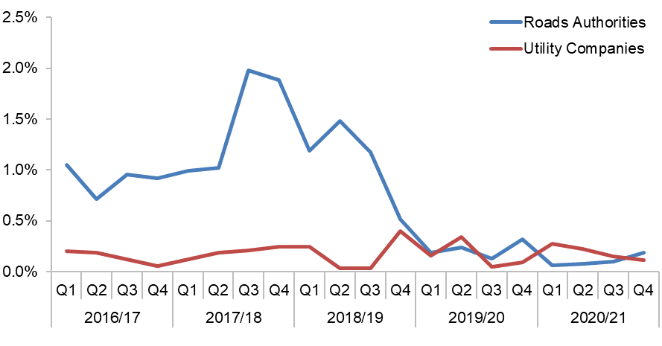

| Period | Roads Authorities | Utility Companies |
| --- | --- | --- |
| 2016/17 Q1 | 0.2% | 1.1% |
| 2016/17 Q2 | 0.2% | 0.7% |
| 2016/17 Q3 | 0.1% | 1.0% |
| 2016/17 Q4 | 0.1% | 0.9% |
| 2017/18 Q1 | 0.1% | 1.0% |
| 2017/18 Q2 | 0.2% | 1.0% |
| 2017/18 Q3 | 0.2% | 2.0% |
| 2017/18 Q4 | 0.2% | 1.9% |
| 2018/19 Q1 | 0.2% | 1.2% |
| 2018/19 Q2 | 0.0% | 1.5% |
| 2018/19 Q3 | 0.0% | 1.2% |
| 2018/19 Q4 | 0.4% | 0.5% |
| 2019/20 Q1 | 0.2% | 0.2% |
| 2019/20 Q2 | 0.3% | 0.2% |
| 2019/20 Q3 | 0.0% | 0.1% |
| 2019/20 Q4 | 0.1% | 0.3% |
| 2020/21 Q1 | 0.3% | 0.1% |
| 2020/21 Q2 | 0.2% | 0.1% |
| 2020/21 Q3 | 0.2% | 0.1% |
| 2020/21 Q4 | 0.1% | 0.2% |

Figure - Roads authorities and utility companies registering works with traffic management type “not yet known”, as a percentage of actual starts

(Source: SRWR Report 24 and SRWR Report 9a)

## Fixed Penalty Notices (FPNs) issued to utility companies

Fixed Penalty Notices (FPNs) are similar in nature to Parking Penalty Charge Notices. Roads authorities are not required by legislation to issue FPNs. Where they are not issued, generally authorities consider that the potential financial returns would not cover the cost of administration.

However, the benefit is improved utility company compliance with road works legislation which may provide them with time and cost savings elsewhere

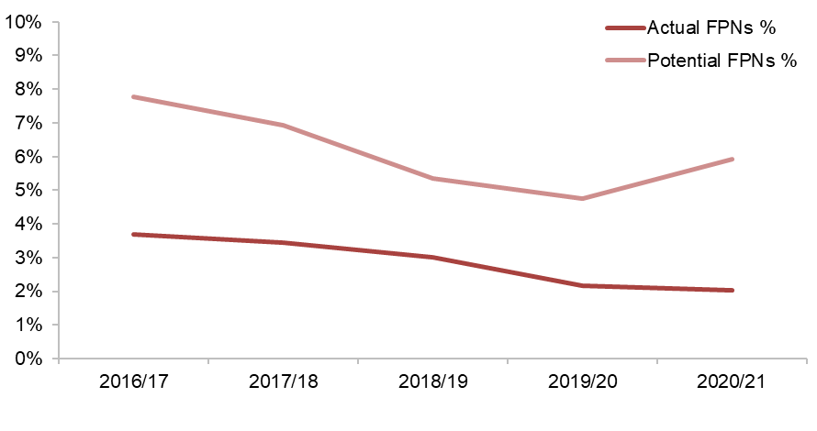

| Period | Actual FPNs % | Potential FPNs % |
| --- | --- | --- |
| 2016/17 | 3.7% | 7.8% |
| 2017/18 | 3.4% | 6.9% |
| 2018/19 | 3.0% | 5.4% |
| 2019/20 | 2.2% | 4.7% |
| 2020/21 | 2.0% | 5.9% |

Figure - Actual and potential fixed penalty notices (FPN’s) issued to utility companies as a percentage of actual starts

(Source: SRWR Report 1 and SRWR Report 9a)

## Undue delay (S125) notices issued by roads authorities and received by utility companies

When a utility company unduly delays completion of their road works, a roads authority has the power, under section 125 of the New Roads and Street Works Act 1991 (NRSWA), to serve an undue delay direction on the utility, directing that the works are completed within a specified time.

| Organisation | 2016/17 | 2017/18 | 2018/19 | 2019/20 | 2020/21 |
| --- | --- | --- | --- | --- | --- |
| Last Mile Electricity Limited | 2 | 6 | 9 | 1 | 0 |
| Scottish & Southern Electricity Networks | 1 | 4 | 5 | 12 | 12 |
| SP Energy Networks | 20 | 11 | 18 | 10 | 18 |
| Energy Assets Pipelines | 0 | 1 | 0 | 0 | 0 |
| ES Pipelines Limited | 0 | 0 | 2 | 0 | 1 |
| Fulcrum Pipeline Limited | 0 | 1 | 0 | 0 | 0 |
| SGN | 2 | 20 | 7 | 14 | 10 |
| Network Rail | 0 | 1 | 0 | 0 | 0 |
| INEOS | 1 | 0 | 0 | 0 | 0 |
| BT | 11 | 57 | 14 | 4 | 11 |
| CityFibre | 0 | 0 | 8 | 15 | 17 |
| EE | 0 | 0 | 0 | 1 | 0 |
| Virgin Media | 7 | 49 | 1 | 3 | 3 |
| Vodafone | 0 | 0 | 0 | 1 | 1 |
| Scottish Water | 20 | 23 | 45 | 43 | 32 |

Table - Undue delay (s125) notices issued by roads authorities and received by utility companies

(Source: SRWR Report 17e)

## Roads authority works registered per 100km

Prior to enactment of the Transport (Scotland) Act 2005, only utility companies were required to register their qualifying road works in the Scottish Road Works Register (SRWR).

Since 2005, roads authorities have also been required to register their qualifying works, however, their performance remains inconsistent and in need of further scrutiny.

This indicator compares roads authority works registered against others with a similar demographic make-up.

This indicator scrutinises the number of road works registered on the SRWR by council roads authorities, Transport Scotland trunk road operating companies and Transport Scotland trunk road DBFO companies across Scotland.

Road works registered are influenced by many factors such as geographic location, political priorities, population, weather, available resources (numbers of operatives), structural and routine budgets, road network lengths, etc. For example, islands and rural authorities register fewer road works than urban authorities. Consequently, for reporting purposes, authorities and transport Scotland operators are grouped with peer organisations and any view on their performance is relative.

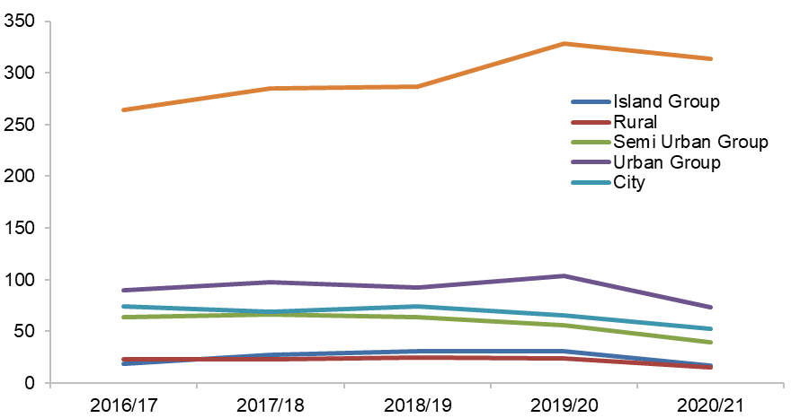

| Organisation | 2015/16 | 2016/17 | 2017/18 | 2018/19 | 2019/20 | 2020/21 |
| --- | --- | --- | --- | --- | --- | --- |
| Island Group | 15.6 | 18.8 | 27.1 | 30.8 | 31.0 | 16.6 |
| Rural | 19.7 | 22.9 | 23.1 | 24.9 | 23.9 | 15.1 |
| Semi Urban Group | 60.6 | 63.8 | 66.6 | 63.5 | 55.8 | 39.1 |
| Urban Group | 81.1 | 89.6 | 97.8 | 92.3 | 103.2 | 73.1 |
| City | 82.7 | 74.2 | 69.4 | 74.0 | 65.3 | 52.3 |
| Transport Scotland | 466.1 | 264.4 | 284.7 | 287.1 | 328.0 | 314.0 |

Figure - Average works per 100km for authorities in each SCOTS group and Transport Scotland

(Source: SRWR Report Works per 100km)

Contact Details

You can phone us on **0131 244 9936**

You can email us at [enquiries@roadworks.scot](mailto:enquiries@roadworks.scot)

Our website is <https://roadworks.scot>

You can contact us by post at:

**Scottish Road Works Commissioner**

**E Spur**

**Saughton House**

**Broomhouse Drive**

**Edinburgh EH11 3XD**

Other Formats

The SRWC is committed to making services, policies and guidance available to everyone. This document may be available in other formats. Please contact us if you wish to discuss this matter.